THE EFFECT OF INFLATION AND COORPORATE SOCIAL RESPONSIBILITY ON SHARE RETURNS WITH PROFITABILITY AS INTERVENING VARIABLES IN THE MINING SECTOR
2017-2019 PERIOD

Verry Allan Dwi Prastyo ⁽¹⁾, Slamet Riyadi ⁽²⁾, Sunu Priyawan ⁽²⁾
⁽¹⁾Faculty0of0Economics0and0Business, 0University0of0170August01945 Surabaya, 0Indonesia
⁽²⁾Faculty0of0Economics0and0Business, 0University0of0170August01945 Surabaya, 0Indonesia
verryad@yahoo.com, slametriyadi10@untag-sby.ac.id, sunu@untag-sby.ac.id

Abstact

This study aims to prove the effect of inflation and coorporated social responsibility on stock returns with profitability as an intervening variable in mining listed on the Indonesia Stock Exchange. The population of this study is 47 mining sector companies listed on the Indonesia Stock Exchange (BEI). The sampling technique uses a purposive sampling method which has certain criteria in taking samples that have an annual financial report 2017-2019, in order to obtain 22 companies. mining sector is listed on the Indonesia Stock Exchange (IDX). The method of this research uses analysis of Structural Equation Modeling (SEM) based on variance, namely Partial Least Square (PLS). SEM with variance-based PLS so that it can handle two conditions, namely conditions with undetermined factors and conditions where the solution cannot be accepted. This study uses a computer program from smart PLS 3.2 which is to determine which variables are significant to stock returns in mining listed0on0the0Indonesia Stock0Exchange0for0the02017-20190period. Based on the results of research that has been done, the variable that has a significant1effect on stock returns is the variable of profitability and the coorporated social responsibility (CSR) variable.
.

Keywords: Stock Return, Profitability, Coorporated Social Responsibility, Inflation, Structural Equation Modeling Partial Least Square (SEMPLS).

- PRELIMINARY

- Background

The growth in stock returns that has been increasing since 2019 can be said to have helped the rate of stock returns that were obtained.

Picture 1
Graph of Go Public Mining Company ROA Development
Source: Secondary Data Processed, 2020

In the graph above, it explains that from the last few years there has been a decline in prices in the mining sector, such as falling prices from coal mining throughout 2019. From this graph throughout 2019 mining companies have experienced a decline such as PT. Adaro Energy Tbk (ADRO) recorded a yield of 12.20%. PT. Aneka Tambang Tbk (ANTM) recorded a yield of 0.61%. PT Atlas Resources Tbk (ARII) recorded a return on assets of 1.46%. PT Baramulti Suksessarana Tbk (BSSR) recorded a yield of 12.5%. PT Cita Mineral Investindo Tbk (CITA) recorded a yield of 0.17%. PT Elnusa Tbk (ELSA) recorded a yield of 5.24%, from the company PT Elnusa Tbk experienced an increase in yield from 2018 to 2019 of 0.4%. PT Surya Esa Perkasa Tbk (ESSA) recorded a yield of 0.07%. PT. Golden Energy Mines Tbk (GEMS) recorded a yield of 8, 4%. PT Harum Energy Tbk (HRUM) recorded a yield of 4.1%. PT Vale Indonesia Tbk (INCO) recorded the same yield from 2018, namely 3%, did not experience a decrease in 2018 to 2019. PT Indo Tambangraya Megah Tbk (ITMG) recorded a yield of 11%. PT Resource Alam Indonesia Tbk (KKGI) experienced an increase from its 2018 to 2019 yield of 3.9% and recorded a yield in 2019 of 4.3%. PT Mitrabara Adiperdana Tbk (MBAP) recorded a yield of 18.33%. PT Merdeka Copper Gold Tbk (MDKA) recorded a yield of 0.81%. PT Medco Energi Internasional Tbk (MEDC) experienced a fairly rapid increase in 2019 reaching 29% and recorded a return of 30%. PT Samindo Resources Tbk (MYOH) recorded a return of 16.3%. PT J Resources Asia Pasifik Tbk (PSAB) recorded a yield of 0.004%. PT Bukit Asam Tbk (PTBA) recorded a return of 15.54%. PT. Petrosea Tbk (PTRO) experienced an increase in 2019 reaching 1.5% and recorded a yield of 5.68%. PT Timah Tbk (TINS) recorded a return of 3%. PT Toba Bara Sejahtera Tbk (TOBA) recorded the same yield for 5 years, namely 0.1%.
So from the observation of the chart above, in 2019, several companies experienced a decline in return on assets. For companies that have increased quite rapidly in 2019, PT Medco Energi Internasional Tbk (MEDC) has achieved an increase of more than 25%.

- Formulation of the problem

Based on the description as explained in the background, the problems in this study are formulated as follows:
- Does inflation have a significant effect on share returns obtained by shareholders from mining companies0 listed0 on0 the0 Indonesia0 Stock0 Exchange0 (IDX) 0for the02017-2019 period?
- Does inflation have a significant effect on the profitability of shareholders from mining companies listed on the Indonesia Stock Exchange (IDX) for the 2017-2019 period?
- Does Corporate social responsibility (CSR) have a significant effect on Share Returns obtained by shareholders from mining companies listed on the Indonesia Stock Exchange (IDX) for the 2017-2019 period?
- Does Corporate social responsibility (CSR) have a significant effect on the profitability of shareholders from mining companies0 listed0 on0 the0 Indonesia0 Stock0 Exchange (IDX) for the 2017-2019 period?
- Does Profitability have a significant effect on the return of shares obtained by shareholders from mining companies0listed0on the0Indonesia0Stock0Exchange0 (IDX) for the 2017-2019 period?

- Literature Review

- Inflation
Inflation is an economic condition in which prices generally experience temporary increases in prices. Inflation is an economic symptom that cannot be completely eliminated. Samuelson (2001) defines inflation as a condition in which there is an increase in the general level of prices, both goods, services and production factors. This definition indicates a state of weakening purchasing power followed by a decline in the real (intrinsic) value of a country's currency.
Based on the price data, an indexed figure is compiled. An index figure that takes into account all goods purchased by consumers at each price is called the consumer price index (CPI or consumer price index = CPI). Based on the consumer price index, it can be calculated how big the rate of increase in prices in general in a certain period. Usually every month, 3 months, and 1 year. Apart from using the CPI, the inflation rate can also be calculated using the GNP or GDP deflator, which is comparing GNP or GDP measured at current prices (GNP or nominal GDP) against GNP or constant price GDP (GNP or real GDP). The formula for calculating the inflation rate is:

$$I_{n}=\frac{{IHK}_{n }{-IHK}_{n-1}}{{IHK}_{n-1}} 100\% I_{n}=\frac{{Df}_{n }{-Df}_{n-1}}{{Df}_{n-1}} 100\%$$
Source: Suriyani (2018)
This is inflation
CPI consumer price index base year (in this case the value is 100)
The CPI-1 is the consumer price index for the following year
Dfn is the GNP or GDP deflator for the following year
Dfn-1 is the GNP or GDP deflator for the initial (previous) year.

- Corporate Social Responsibility (CSR)
Corporate Social Responsibility (CSR) is a business operation committed not only to increasing corporate profits financially, but also to the region's socio-economic development in a holistic, institutional and sustainable manner. CSR is how a company manages a company, both partially and as a whole, which has a positive impact on itself and the environment (Johnson and Johnson in Hadi, 2011). Conceptually there are three approaches in the formation of social responsibility, as follows:
- A moral approach, namely a policy based on the principle of decency and prevailing positive values, with the understanding that what is done does not violate or harm other parties.
- The common interest approach states that moral policies must be based on the standard of togetherness, fairness, openness and freedom.
- The benefits approach is a social responsibility concept based on the values ​​that what the organization does must be able to produce great benefits for interested parties fairly.
The development of social responsibility in 1997 was colored by various approaches, such as the integral approach, the stakeholder approach and the civil society approach (Wibisono, 2007). One of the well-known is the theory of "The Triple Bottom Line" put forward by John Elkington, a British businessman through his book "Cannibals with Forks: The Triple Bottom Line of 21st Century Business".
Elkington developed the Triple Bottom Line concept with the terms economic prosperity, environmental quality, and social justice. This concept holds that if a company wants to maintain its survival, then the company must pay attention to 3P, in addition to pursuing profit, the company must also pay attention to and be involved in fulfilling the welfare of the community (people), and contribute actively to preserving the environment (planet).

Picture 2
Triple Bottom Line Concept
Source: WBCSD, 2004.

According to the Global Reporting Initiative (GRI) in Nuryaman (2013), to calculate CSR disclosure items in the company's annual report using the formula for the Corporate Social Responsibility Disclosure Index (CSRDI), as follows:

CSRDIj =$\frac{\sum{X_{ij}}}{N_{j}}$
(source: Putri, 2014)
CSRDIj = Corporate Social Responsibility Disclosure Index
$\sum{X_{ij}}$ = The number of items disclosed by the company j
$N_{j}$ = The number of items that the company should disclose j

- Profitability
According to Sutrisno (2009: 16) "profitability is the company's ability to generate profits with all the working capital in it. Profitability0according0to0Sofyan0Syafri0Harahap (2009: 304) 0is0"Describing the company's ability0to0earn profits through0all existing capabilities and0resources0such0as0sales0activities, 0cash, 0capital, number0of0employees, number of company branches, 0and0so on".
Large sales and investments are needed and affect the size of the profitability ratio, the greater the sales and investment activity, the greater the profitability ratio. In general, there are four main types of analysis used to assess that the level of profitability, namely, according to Kasmir (2008: 199).

- Net Profit Margin (NPM)
According to Riyanto (2013: 336) "Net Profit Margin is a ratio that measures net profit per rupiah sales". According to Riyanto (2013: 336) "Net0Profit0Margin is the ratio between net operating income and net sales. Net Profit Margin is the ratio used to measure the profit margin on sales. This ratio will describe the company's net income based on total net sales.

$$NPM=\frac{Laba setelah pajak}{penjualan}$$
(Source: Kasmir, 2012: 200)

- Return On Asset (ROA)
Return on assets by0Kasmir (2012: 201)0is0a0"ratio0shows0the0results0of0the0total0assets used0in0the0corporation". by Toto Prihadi (2008), ROA aims to measure the company's ability to utilize assets to earn profits and measure the total results for all creditors and shareholders as providers of sources of funds. According to Toto Prihadi (2008: 68) "Return0on0assets0is0the ratio0used0to0measure0the0level0of0profit0to0assets0used0to0generate0these0profits".
This percentage is expressed by the following formula:

$$ROA=\frac{Laba setelah pajak}{Total aktiva}$$
(Source: Fahmi, 2015: 137)

- Return On Equity (ROE)
According0to0Brigham0&0Houston0 (2010), 0 “Return0On0Equity, 0namely0the0ratio0of net0income0to0ordinary0equity, 0measures 0the 0rate 0of 0return 0on 0investment0of0shareholders. Meanwhile, 0according0to0Tandelin "Return On Equity describes the extent to which the company's ability to generate profits that can be obtained by shareholders". According0to0Sawir (2009: 20) "Return0On0Equity0is a0ratio0shows0the0extent0to0which a corporation0manages its own0capital0effectively0to0measure0from level0of0return0on0investment0has0been0made0by0own capital owners or company shareholders". This percentage is expressed by the following formula:

$$ROE=\frac{Laba setelah pajak}{Modal sendiri}$$
(Source: Fahmi, 2015: 137)

- Earning0Per0share0 (EPS)
Earning per share0is0a0ratio0that describes 0the 0amount 0of 0rupiah 0earned 0for0 each common0share0 (Syamsuddin, 2009: 66). According0to0Sofyan0Syafri0Harahap 2008: 306 "Earning Per Share is a ratio that shows how0much0the0ability per share to0generate profits". Therefore,0in general,0 corporate0 management0 companies,0 common0 shareholders 0and0 prospective0 shareholders0are very0interested0in0Earning0Per0Share. Earning Per Share is0an0indicator0of0the0success0of a0company.

$$EPS=\frac{Laba setelah pajak}{Jumlah lembar saham beredar}$$
(Source: Fahmi, 2015: 137)

- Return Stock
Fahmi and Yovi (2009) state that stock returns are the benefits that companies, individuals and institutions receive from the results of their investment policies. The higher the stock return, the better the investment because it can generate profits, on the contrary, the more the stock return or even negative, the worse the investment return. Stock is showing ownership rights in the profits and assets of a company. In0simple0terms, investment can be defined as the activity of placing funds in one or more assets during a certain period in the hope of obtaining income or an increase in investment value. In investing, Systematically, 0the0calculation0of stock0returns0according0to0Hartono0 (2013) is as0follows:
RIT = $\frac{\left(P_{t}-P_{t}-1+D_{t}\right)}{P_{t}-1}$
(Source: Fahmi, 2015: 137)
Information :
Rit | : rate0of0return0on shares in I in period t.
Pt | : the results of the closing of shares I in period t (closing period / last)
Pt-1 | : the0closing0price0of0shares I0in0the0previous0period.
Dt | : periodic0dividends.

- Research methods

- conceptual framework
Based on literature review, previous research and hypothesis development, the concept of this research can be formulated through the following framework:
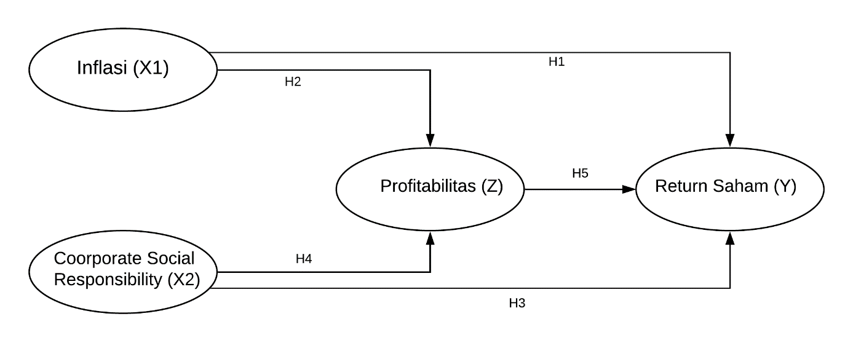
Picture 3
conceptual framework

- Purposive Sampling
While the sample selection using purposive0sampling0technique, 0namely0the0sampling technique0of data sources with0certain0considerations, (Sugiyono, 2009).

Table 1
Purposive Sampling Results
Sample Criteria | total
The number of mining coorporation0that0have0been0and0are still0registered0on0the0Stock0Exchange0Indonesia0for the0period 2017-2019 | 46
Deduction 1:  Mining companies that did not have financial reports in a row during the 2017 - 2019 period | (6)
Deduction 2:  Mining companies that do not have a CSR record | (15)
Deduction 3:  There is no availability of variable data under study | (3)
Total Samples | 22

- Results and Discussion

- Statistic analysis

Descriptive0statistical0analysis0provides0a0general0description0of the0data0in0the0form of0mean, 0standard0deviation, 0lowest0value0and0highest0value. The results0of0the0descriptive analysis are as follows:

Table 2
Descriptive0statistics
Indicator | Minimum0 | Maximum0 | Mean0 | Std. Deviation0
Inflation Rate | 2,720 | 3,610 | 3,153 | 0.367
ROA | 0.010 | 39,410 | 9,358 | 8,728
ROE | 0.190 | 55,250 | 16,553 | 13,590
NPM | 0.270 | 74,050 | 13,816 | 12,766
EPS | 0.000 | 477,000 | 33,338 | 94,540
Economy | 0.037 | 0.130 | 0.109 | 0.023
Environment | 0.000 | 0.481 | 0.165 | 0.152
Social | 0.000 | 0.148 | 0.082 | 0.035

- Evaluate the Outer Model

Evaluation0of the measurement0model0is a stage0to0evaluate the0validity0and0reliability of a0construct, 0which0consists0of0evaluation0of0 construct0 validity0 and0 evaluation 0of0 construct reliability. 0Each0will0be0explained0as0follows:
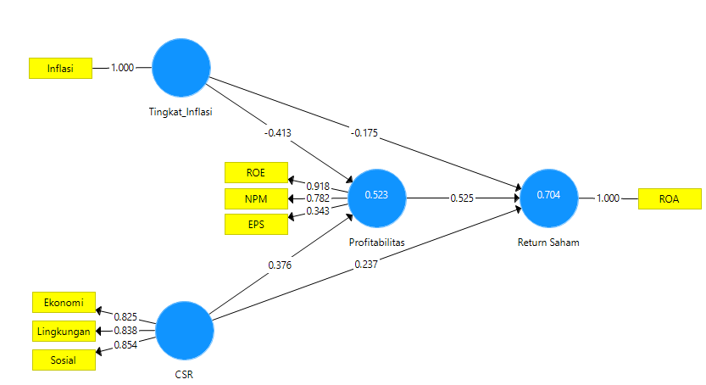
Picture 4
Outer Model construct

- Hypothesis test

Significance0testing0is0used0to0test0the0influence0of0exogenous0variables0on0endogenous0variables. 0The0test0criteria0states0that0if0the0value0T-statistics ≥0T-table0 (1.96) 0or0P-Value <0significant0alpha05%0or00.05, 0it0is0stated0that0there0is0a0significant0effect0of0exogenous variables0on0endogenous0variables. 0The0results0of0the0significance0and0model0testing0can0be seen0through0the0following0figures0and0tables.
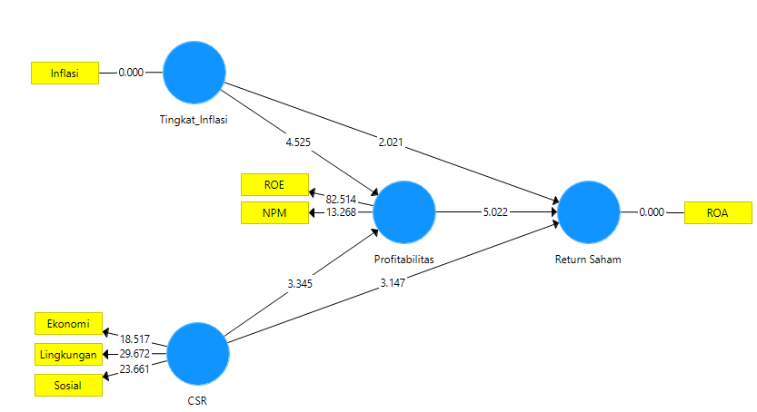
Picture 5 Inner Model construct

Table 9 Hypothesis Testing Results
No. | Corellation between variables | Original Sample (O) | T Statistics (| O / STDEV |) | P Values | Information
1. | Inflation Rate -> Stock Return | -0.167 | 2,021 | 0.044 | Significant
2. | Inflation Rate -> Profitability | -0,428 | 4,525 | 0.000 | Significant
3. | CSR -> Stock Return | 0.238 | 3,147 | 0.002 | Significant
4. | CSR -> Profitability | 0.366 | 3,345 | 0.001 | Significant
5. | Profitability -> Stock Return | 0.529 | 5,022 | 0.000 | Significant

- Hypothesis 1 The inflation rate0has0a0significant0effect0on0stock0returns0in0mining sector0listed0on0the0IDX for the 2017 - 20190period.
In0the0results0listed0in0the0 table0 above0 it0 can0 be0 seen0 that0 the0 test Influence Inflation rate towards stock returns0in0mining0companies0listed0on0the0IDX0for0the period 2017 - 2019 produce score T statistics> 1.960with0a p-value0<0.05. It0can0be concluded0that there0is a0significant0influence on the level of inflation on stock returns in mining0companies0listed0on0the IDX for the period 2017 - 2019.Thus hypothesis 1 in this study is fulfilled. The resulting coefficient is -0.167 (negative) which means, if the inflation rate increases by 1% it tends to decrease Stock Return of 0.167%. The0results of0this0study0indicate0how0inflation0has a0significant0effect0on0stock returns. Where inflation increases, stock returns will decrease, and vice versa. If inflation decreases, the return on stock obtained for investors will increase. This study is supported by the results of research by Djayani Nurdin (1999) entitled Investment Risk in Property Shares on the Jakarta Stock Exchange with the result that inflation has a significant effect on the risk of investing in property stocks on the Jakarta Stock Exchange.

- Hypothesis 2 The inflation0rate0has0a0significant0effect0on0profitability0in mining sector0listed0on0the0IDX0for0the0period02017 - 2019.
In0the0results0listed0in0the0table0above0it0can0be seen that the test Influence Inflation rate towards0profitability0in0mining0companies listed on the0IDX0for0the period02017 - 2019 produce0score0T0statistics> 1.960with0a p-value0<0.05. 0It0can0be concluded0that0there0is a significant influence on the level of inflation on profitability of mining companies listed on the IDX for the period 2017 - 2019.Thus, 0hypothesis02 in0this0study0is0fulfilled. 0The0resulting0coefficient is -0.428 (negative) which means, if the inflation rate increases by 1% it tends to decrease Profitability of 0.428%. The0results of0this0study0indicate0how inflation has0a0significant0effect on profitability. Thus the results0of0this0study0are in accordance with previous research0from0Hidayati (2016) which states that0inflation has0a positive0and0significant0effect0on0profitability.

- Hypothesis 3 CSR (Corporate social responsibility) 0has0a0significant0effect0on stock0returns0in0mining0sector0listed0on0the0IDX0for0the0period 2017 - 2019.
In0the0 results0 listed0 in0 the0 table0 above 0it0 can0 be0 seen0 that0 the0 test0 Influence CSR (Corporate social responsibility) on stock returns in mining companies listed on the IDX for the period 2017 - 2019 produce score T statistics> 1.96 with a p-value <0.05. It can be concluded that there is a significant effect of CSR (Corporate social responsibility) on stock returns in mining companies listed on the IDX for the 2017 - 2019 period.Thus, hypothesis 3 in this study is fulfilled. The resulting coefficient is 0.238 (positive), which means that if CSR increases by 1 unit then it tends to0increase0Stock0Return0of 0.238%.The0results0of0this0study0 indicate0 that0 CSR0 has0 a0 significant0 effect0 on stock returns. 0This0shows0that0the higher the0company applies the0disclosure0of0corporate social0responsibility0 (CSR), the greater0impact on stock returns. The0results0of0this study0 indicate0 that0CSR0 disclosure0 has0 a0 significant0 effect0 on0 stock0 returns, 0which indicates0 that0 investors0 consider0 CSR0 information0 to0 make0 decisions. Consistent with research by Kim, et al (2014) and Cheng and Yulius (2011) which show that CSR affects stock returns. This0research0is0supported0by0the0results0of0research0from Prasetyo (2017), Gantino (2016), Putri (2014), Rosdwianti (2016) and Citraningrum (2014) which state that0CSR0disclosure0has0a0significant0effect0on0company ROA.

- Hypothesis 4 Corporate Social Responsibility has0a0significant0effect0on profitability in mining0sector0listed0on0the0IDX0for0the0period 2017 - 2019.
In0the0results0listed0in the0table0above0it0can0be0seen that the test Influence CSR (Corporate social responsibility) on profitability in0mining0companies0listed0on0the IDX0for0the0period02017 - 2019 produce score T statistics> 1.960with0a0p-value0<0.05. It0 can0 be0concluded0 that0 there0 is0 a0 significant0 effect of CSR (Corporate social responsibility) on profitability in0mining0companies0listed0on0the0IDX0for0the0period 2017 - 2019.Thus, hypothesis 4 in this study is fulfilled. The resulting coefficient is 0.366 (positive), which means that if CSR increases by 1 unit then it tends to increase Profitability of 0.366%.0 The0 results0 of0 this0 study0 indicate0 that0 Corporate0 Social Responsibility has an influence on profitability. This0research0is supported0by0the results0of0recent0research0conducted0by0Feb0Tri0Wijayanti, 0Sutaryo0and0Muhammad Agung0Prabowo0 (2011).

- Hypothesis 5 Profitability0 has0 a0 significant0 effect0 on0 stock0 returns0 in0 mining sector0listed0on0the IDX0for0the0period 2017 - 2019.
In0the0results0listed0in0the0table0above0it0can0be0seen0that0the test Influence Profitability on stock returns in0mining0companies0listed0on0the0IDX0for0the0period 2017 - 2019 produce score T statistics> 1.960with0a0p-value0<0.05. It0can0be concluded0that0there0is a0significant0effect0of0profitability0on stock returns in0mining companies0listed0on0the0IDX0for0the0period02017 - 2019.Thus, hypothesis 5 in this study is fulfilled. The resulting coefficient is 0.529 (positive) which means, if profitability increasesat 1% then it tends to0increase0Stock0Return of 0.529%. The results0 of 0this 0study 0indicate 0how 0profitability 0has 0a 0significant 0effect 0on 0stock returns. 0The positive relationship obtained in the results of this study means that if profitability (ROE) increases, stock returns will also increase. Investors0pay0attention to0the0value of ROE in0making0investment decisions in consumer goods companies. The0results0of0this0study are0supported0by0research0conducted0by0Wong Pik Har & Ghafar (2015), Andansari et al. (2016) and Apriliani & Hartini (2016) who state that ROE affects stock returns.

- CONCLUSION0

Based0on0the0results0of0data0research0on0Inflation and0Corporate0Social0Responsibility (CSR) 0on0Stock0Returns0with0Profitability as an intervening variable for Mining0sector0listed on00the0 Indonesia0 Stock0 Exchange0(IDX) 0for00the002017-201900period,0the0following conclusions0can be drawn in this study. Based0on0the0results of the model estimation, it0can0be seen:
- Inflation0has0an effect on the return of shares0obtained by shareholders of mining companies listed0on0the0Indonesia0Stock0Exchange0 (IDX) 0for the 2017-20190period.
- Inflation affects the profitability of shareholders from mining companies listed0on0 the Indonesia0Stock0Exchange (IDX) for the 2017-20190period.
- Corporate social responsibility (CSR) has an effect on Stock Returns obtained by shareholders from mining companies0listed0on0the0Indonesia0Stock0Exchange0 (IDX) 0for the 2017-2019 period.
- Corporate social responsibility0 (CSR) 0has0an effect on the profitability of shareholders from mining companies listed0on0the0Indonesia0Stock0Exchange (IDX) for the 2017-2019 period.
- Profitability affects0the return of shares obtained by shareholders from mining companies listed0on0the0Indonesia 0Stock Exchange (IDX) for the 2017-2019 period.

REFERENCES
[1] Christiawan, Yulius Jogi. Rafika Anggraini Putri. (2014). "The Effect of Profitability,Liquidity, and Leverage on Disclosure of Corporate Social Responsibility ".
[2] wahyuningsih djayani nurdin. Journal of Business Management 3 (1), 59-86, 2010. 8 *, 2010. Investment Risk in Property Shares on the JSE. N Djayani. Businessman, 1999
[3] Fahmi, Irham. 2015. Introduction to Financial Management Theory and Questions and Answers. Bandung: Alfabeta.
[4] Hadi, Nor. 2011. Corporate Social Responsibility. First Cet.Yogyakarta: Graha Ilmu.
[5] Cashmere. (2012), Financial Statement Analysis. Jakarta: PT. Raja Grafindo Persada.
[6] Nuryaman. 2013. The Effect of Corporate Social Responsibility Activities on Profitability and Stock Price (Studies on The Companies Listed on Indonesia Stock Exchange). 4th International Conference on Business and Economic Research (4th ICBER 2013) Proceeding: 756-769.
[7] Samuelson, Paul A. and William D. Nordhaus, 2001. Macroeconomics. Seventeenth Edition. McGraw-Hill Higher Education.
[8] Sugiyono, 2009, Quantitative Research Methods, Qualitative and R & D, Bandung: Alfabeta.
[9] Suriyani and Sudiartha, 2018. THE EFFECT OF INTEREST RATE, INFLATION AND EXCHANGE RATE ON SHARE RETURNS IN INDONESIA STOCK EXCHANGE. E-Journal of Management of Udayana University, Vol. 7, No. 6, 2018: 3172-3200
[10] World Business Council for Sustainable Development 2002, Corporate Social Responsibility: The WBCSD's journey, pp. 1. Retrieved May, 2015, from http://www.wbcsd.org
[11] http://www.idx.co.id/
[12] https://www.ojk.go.id
[13] https://id.investing.com/
[14] https://www.bi.go.id/

