Lampiran 1
Tabulasi Skala Fear Of Missing Out (FOMO)

TABULASI FEAR OF MISSING OUT (FOMO)
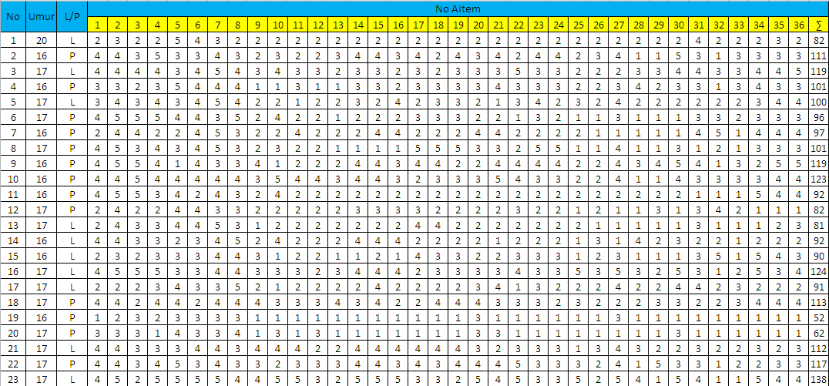
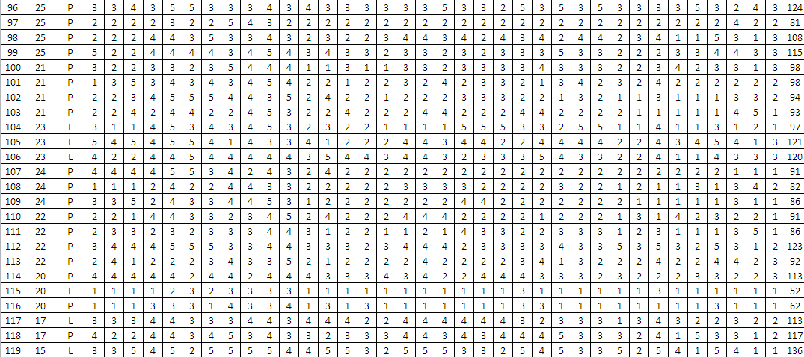
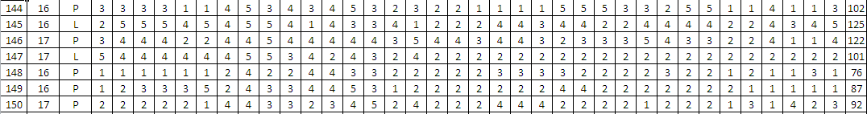
Lampiran 2
Tabulasi Skala Kebutuhan Afiliasi

TABULASI SKALA KEBUTUHAN AFILIASI
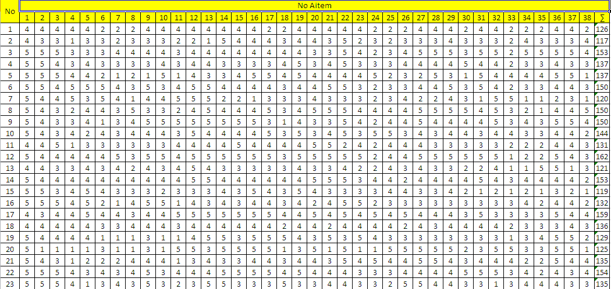
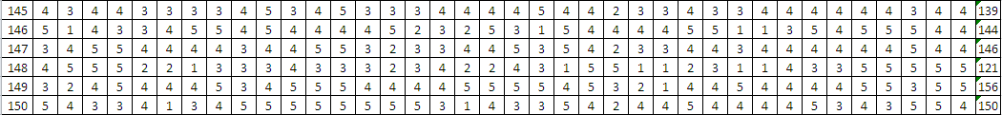

Lampiran 3
Tabulasi Skala Tipe Kepribadian Ekstrovert

TABULASI DATA TIPE KEPRIBADIAN EKSTROVERT
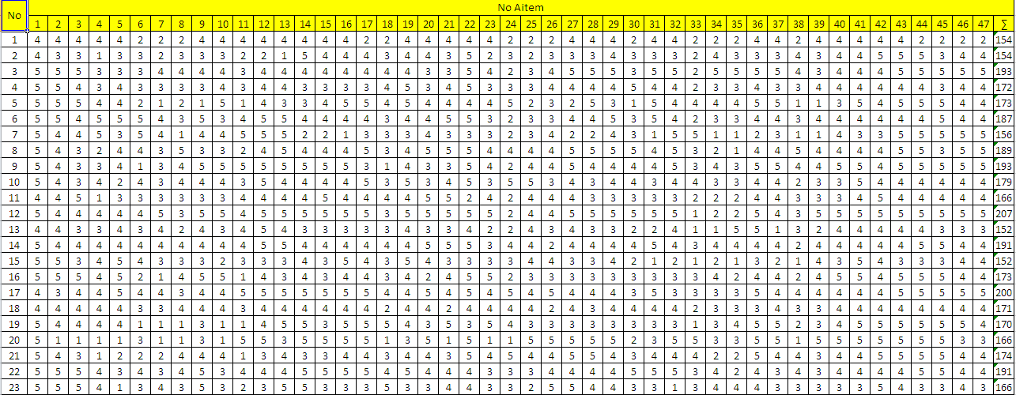

Lampiran 4
Kuisioner Skala Fear Of Missing Out (FOMO)

Nama (boleh inisial) :
Umur :
Jenis kelamin :
PETUNJUK PENGISISAN
- Bacalah setiap pernyataan – pernyataan pada lembar berikut, kemudian jawablah sesuai dengan keadaan yang sebenarnya.
- Tidak ada jawaban benar atau salah, semua jawaban dianggap benar jika diisi dengan jujur dan sesuai dengan kondisi saat ini.
- Pilihlah 1 dari 5 jawaban yang paling sesuai dengan keadaan saat ini dengan memberikan tanda centang (√ ) pada kolom yang sudah disediakan dengan ketentuan: (SS) Sangat Setuju, (S) Setuju, (N) Netral, (TS) Tidak Setuju, (STS) Sangat Tidak Setuju.

Skala 1
No | Pernyataan | SS | S | N | TS | STS
1. | Saya cemas ketika tidak dapat membuka akun media social
2. | Saya cemas ketika fungsi smartphone saya eror
3. | Setiap saat saya membuka media sosial yang aktif
4. | Saya biasa saja saat tidak dapat update terbaru dari teman melalui media social
5. | Saya tidak cemas sekalipun tidak mendapat update tentang teman melalui media social
6. | Saya cemas ketika tidak mendapat update terbaru dari teman di media social
7. | Ketika daya smartpohne akan habis, saya sesegera mungkin pergi ke cafe terdekat yang menyediakan pengisi daya
8. | Saya cemas ketika melewatkan momen teman di media social
9. | Saya tidak tenang saat berlibur, saya tidak dapat memantau aktivitas teman di media social
10. | Saya tidak tenang bila terlambat membaca chat komentar di media sosial
11. | Saya takut tidak dilibatkan dalam diskusi bersama teman
12. | Saya takut tidak dilibatkan dalam kegiatan yang dilakukan teman melalui group wa
13. | Saya takut bila tidak dimintai pendapat dalam percakapan di group wa
14. | Saya tidak takut bila diabaikan dalam percakapan dalam group media sosial
15. | Saya tidak takut bila kurang update dengan info teman
16. | Saya biasa saja sekalipun tidak dilibatkan dalam diskusi group di media sosial
17. | Penting bagi saya untuk tidak melewatkan kegiatan yang dilakukan teman-teman di media sosial
18. | Saya takut bila tidak mengetahui yang sedang dibicarakan oleh teman-teman di group media sosial
19. | Saya takut tidak diajak untuk berkumpul bersama teman-teman group media sosial
20. | Saya tidak membuang waktu dengan mencari berita teman di media sosial
21. | Saya tidak membuang waktu untuk membaca berita teman di media sosial
22. | Saya menghabiskan setiap menit waktu saya untuk mencari tahu keadaan teman-teman di media sosial
23. | Saya rajin memberi komentar pada postingan teman
24. | Saya lupa waktu saat membuka media social
25. | Saya rajin memposting quote
26. | Saya mudah curhat melalui media social
27. | Saya memposting apapun yang menarik di media social
28. | Saya enggan update status di media social
29. | Tidak perlu memamerkan kebahagiaan saya di media social
30. | Saya rajin update diri di media social
31. | Ketika sedang berlibur, saya tidak lupa untuk memposting semua kegiatan
32. | Saya tetap tenang selama tidak dapat mengakses internet
33. | Saya biasa saja sekalipun internet sedang trouble
34. | Saya tidak takut saat tidak dapat mengakses internet
35. | Saya frustasi saat ada kendala dalam media sosial
36. | Saya frustasi saat koneksi internet trouble

Lampiran 5
Kuisioner Skala Kebutuhan Afiliasi

Skala 2
No | Pernyataan | SS | S | N | TS | STS
1. | Saya senang ketika berpergian bersama teman
2. | Saya menyukai pesta
3. | Saya senang jika disekitar ada banyak teman
4. | Saya lebih baik menolak diminta bekerjasama secara kelompok
5. | Saya senang mengerjakan tugas bersama teman
6. | Saya memilih bekerjasama dengan teman daripada kerja sendiri
7. | Saya menjaga komunikasi dengan teman sekalipun lama tidak bertemu
8. | Saya senang saat teman-teman memperdulikan saya
9. | Saya senang ketika ada yang menanyakan keadaan saya
10. | Saya tidak suka diperhatikan teman
11. | Saya tidak perduli jika orang lain memperhatikan saya
12. | Saya terbiasa untuk mandiri, tidak butuh perhatian dari orang lain
13. | Saya tidak membutuhkan penghargaan dari orang lain
14. | Saya senang teman mengapresiasi hasil ide saya
15. | Saya senang ada orang yang memuji usaha saya
16. | Saya mampu membuat keputusan sendiri tanpa saran dari orang lain
17. | Saran dari orang lain hanya akan menggoyahkan pendapat saya
18. | Saya meminta saran dari teman-teman untuk membuat keputusan
19. | Saya memperhatikan pendapat teman
20. | Saya senang jika dapat membahagiakan teman
21. | Saya senang biladapat membuat teman tertawa
22. | Saya senang membuat lelucon untuk menghibur teman
23. | Menurut saya, tidak perlu membuat orang lain senang
24. | Menurut saya, tidak perlu membuat teman senang
25. | Saya memuji hasil orang lain yang lebih baik dari saya
26. | Menurut saya, menjalin hubungan baik dengan teman itu perlu agar tetap dipercaya
27. | Saya membantu dengan ikhlas agar teman saya merasa nyaman
28. | Saya tidak perduli sekalipun tidak dipercaya oleh teman
29. | Saya menolak saran dari teman sekalipun itu membuat tidak respect
30. | Tidak perlu menepati janji teman
31. | Saya mudah mengabaikan janji teman
32. | Saya sedih ketika ditinggalkan oleh teman
33. | Saya senang jika ada orang yang menghibur saya ketika gagal
34. | Saya tidak membutuhkan dukungan dari teman
35. | Keberhasilan saya karena kemampuan diri sendiri bukan dari dukungan teman
36. | Menurut saya, menyelesaikan sesuatu itu tidak harus membutuhkan dukungandari teman
37. | Keberhasilan saya karena dukungan dari teman
38. | Ketika sedang cemas, saya meminta dukungan dari teman

Lampiran 6
Kuisioner Skala Tipe Kepribadian Ekstrovert

Skala 3
No | Pernyataan | SS | S | N | TS | STS
1. | Saya dapat menyeleksaikan tugas yang menggunakan kemampuan fisik
2. | Saya mencari kegiatan yang membuat saya bergerak daripada harus berdiam diri
3. | Saya dapat menyelesaikan pekerjaan dengan cepat
4. | Saya enggan bila disuruh melakukan tugas yang menggunakan kemampuan fisik
5. | Biasanya saya menyelesaikan makan lebih cepat daripada teman
6. | Saya lincah menyelesaikan tugas yang menggunakan kemampuan fisik
7. | Saya menghindari aktivitas sosial
8. | Saya mudah terlibat dalam suatu kegiatan sosial di lingkungan sekolah
9. | Saya luwes di lingkungan baru
10. | Saya cenderung berhati-hati dalam situasi yang baru
11. | Saya mencoba hal-hal baru yang menantang adenalin
12. | Bagi saya, hidup tanpa tantangan adalah menjemukkan
13. | Saya menyukai hidup yang rutin
14. | Saya berani menghadapi resiko akibat dari perbuatan yang saya lakukan dengan tenang
15. | Saya suka berganti pekerjaan yang mengharuskan saya untuk berpergian (tugas luar) yang tentunya penuh resiko dan kurang aman
16. | Saya mudah membuat keputusan dengan segera tanpa meikirkan resikonya
17. | Saya enggan menganalisa hasil keputusan yang sudah saya ambil
18. | Ketika mengambil keputusan, saya tidak menimbang dengan teliti untung ruginya
19. | Saya memikirkan secara matang sebelum mengambil keputusan
20. | Saya lebih suka melakukan sesuatu yang telah saya rencanakan terlebih dahulu
21. | Seringkali say amembuat kesimpulan dengan cepat terhadap suatu persoalan
22. | Saya mengerjakan sesuatu yang membuat hati saya senang saja
23. | Saya mudah menghamburkan uang sesuka hati
24. | Saya abaikan orang yang terganggu dengan suara keras saya saat berbicara, yang penting informasi yang saya sampaikan jelas
25. | Saya sesuka hati bernyanyi dengan keras meskipun di tempat umum
26. | Saya berfikir matang sebelum membuat keputusan
27. | Saya memikirkan resiko akan keputusan yang akan saya ambil
28. | Saya sering bertindak sesuka hati
29. | Ketika bosan terhadap suatu pekerjaan, saya akan mengundurkan diri
30. | Seringkali saya menemui kesulitan karena melakukan sesuatu tanpa dipikir terlebih dahulu
31. | Saya mampu memperlihatkan ekspresi tenang meskipun dalam keadaan cemas
32. | Saya enggan menunjukkan ekspresi marah pada orang lain
33. | Saya lebih baik diam tidak perlu menunjukkan yang sedang saya rasakan
34. | Menurut saya, berfikir panjang itu perlu sebelum bertindak
35. | Saya berhati-hati dengan memikirkannya terlebih dahulu sebelum melakukannya
36. | Bagi saya, tidak perlu dipikir saat hendak melakukan sesuatu
37. | Menurut saya, daripada terlalu lama dipertimbangkan lebih baik langsung dikerjakan
38. | Bagi saya, lakukan saja apapun yang terjadi dan hadapi saja
39. | Saya biasa melakukan sesuatu tanpa rencana
40. | Saya mudah terlambat saat janjian bertemu dengan teman
41. | Menurut saya, membuang sampah tidak pada tempatnya selama sedikit itu boleh
42. | Saya sering lupa mengembalikan barang yang saya pinjam
43. | Saya tepat waktu dalam menyelesaikan tugas
44. | Saya mengiyakan ajakan teman untuk bermain, meskipun tugas saya sudah ditunggu oleh teman kelompok
45. | Saya mudah melupakan tugas yang jadi tanggung jawab saya
46. | Saya tegas pada pendirian
47. | Saya konsisten dengan keputusan yang saya buat

Lampiran 7
Hasil Uji Validitas dan Reliabilitas Fear Of Missing Out (FOMO)

HASIL VALIDITAS DAN RELIABILITAS VARIABEL
FEAR OF MISSING OUT (FOMO)
Putaran Pertama

Reliability Statistics
Cronbach's Alpha | N of Items
.853 | 36

Item-Total Statistics
 | Scale Mean if Item Deleted | Scale Variance if Item Deleted | Corrected Item-Total Correlation | Cronbach's Alpha if Item Deleted
VAR00001 | 102.30 | 281.617 | .417 | .848
VAR00002 | 101.89 | 276.417 | .441 | .847
VAR00003 | 102.30 | 281.972 | .308 | .850
VAR00004 | 101.92 | 279.759 | .402 | .848
VAR00005 | 101.78 | 279.958 | .366 | .849
VAR00006 | 101.75 | 278.898 | .332 | .850
VAR00007 | 102.26 | 284.509 | .286 | .851
VAR00008 | 101.60 | 288.546 | .173 | .853
VAR00009 | 102.40 | 278.658 | .368 | .849
VAR00010 | 102.50 | 287.150 | .183 | .853
VAR00011 | 102.36 | 286.421 | .238 | .852
VAR00012 | 102.64 | 285.282 | .293 | .851
VAR00013 | 102.51 | 288.201 | .129 | .856
VAR00014 | 102.62 | 278.276 | .496 | .846
VAR00015 | 102.53 | 279.845 | .441 | .847
VAR00016 | 102.66 | 282.922 | .353 | .849
VAR00017 | 102.45 | 279.401 | .485 | .847
VAR00018 | 102.48 | 280.011 | .481 | .847
VAR00019 | 101.96 | 274.878 | .424 | .847
VAR00020 | 102.48 | 284.327 | .314 | .850
VAR00021 | 102.49 | 283.138 | .354 | .849
VAR00022 | 102.26 | 277.117 | .395 | .848
VAR00023 | 102.03 | 278.107 | .395 | .848
VAR00024 | 102.48 | 283.631 | .337 | .850
VAR00025 | 102.13 | 275.381 | .381 | .848
VAR00026 | 102.58 | 286.877 | .184 | .853
VAR00027 | 101.84 | 275.057 | .434 | .847
VAR00028 | 102.58 | 282.650 | .245 | .852
VAR00029 | 103.04 | 285.821 | .252 | .851
VAR00030 | 102.25 | 274.000 | .445 | .847
VAR00031 | 102.81 | 282.981 | .343 | .849
VAR00032 | 102.60 | 279.065 | .292 | .851
VAR00033 | 102.99 | 279.595 | .437 | .847
VAR00034 | 102.60 | 281.950 | .320 | .850
VAR00035 | 102.42 | 277.852 | .372 | .849
VAR00036 | 102.64 | 277.890 | .471 | .846

Putaran Kedua Done

Reliability Statistics
Cronbach's Alpha | N of Items
.858 | 32

Item-Total Statistics
 | Scale Mean if Item Deleted | Scale Variance if Item Deleted | Corrected Item-Total Correlation | Cronbach's Alpha if Item Deleted
VAR00001 | 90.34 | 250.137 | .424 | .853
VAR00002 | 89.92 | 245.058 | .451 | .852
VAR00003 | 90.34 | 250.529 | .311 | .856
VAR00004 | 89.96 | 249.739 | .368 | .854
VAR00005 | 89.82 | 248.112 | .383 | .854
VAR00006 | 89.79 | 247.676 | .333 | .856
VAR00007 | 90.30 | 253.564 | .271 | .857
VAR00009 | 90.43 | 250.361 | .296 | .856
VAR00011 | 90.40 | 255.772 | .211 | .858
VAR00012 | 90.68 | 255.283 | .245 | .857
VAR00014 | 90.65 | 248.316 | .460 | .852
VAR00015 | 90.57 | 248.183 | .457 | .852
VAR00016 | 90.70 | 251.706 | .349 | .855
VAR00017 | 90.48 | 248.087 | .491 | .852
VAR00018 | 90.52 | 248.580 | .490 | .852
VAR00019 | 89.99 | 242.892 | .449 | .852
VAR00020 | 90.52 | 252.669 | .321 | .856
VAR00021 | 90.53 | 251.377 | .366 | .855
VAR00022 | 90.30 | 247.513 | .358 | .855
VAR00023 | 90.07 | 245.027 | .447 | .852
VAR00024 | 90.52 | 251.618 | .357 | .855
VAR00025 | 90.17 | 242.433 | .425 | .853
VAR00027 | 89.88 | 241.815 | .491 | .851
VAR00028 | 90.62 | 252.061 | .226 | .859
VAR00029 | 91.08 | 254.501 | .245 | .857
VAR00030 | 90.29 | 244.523 | .411 | .853
VAR00031 | 90.84 | 250.437 | .380 | .854
VAR00032 | 90.64 | 245.512 | .343 | .856
VAR00033 | 91.03 | 249.025 | .419 | .853
VAR00034 | 90.64 | 250.472 | .324 | .856
VAR00035 | 90.45 | 246.996 | .366 | .855
VAR00036 | 90.68 | 246.245 | .488 | .851

Lampiran 8
Hasil Uji Validitas dan Relibilitas Kebutuhan Afiliasi

HASIL VALIDITAS DAN RELIABILITAS VARIABEL
KEBUTUHAN AFILIASI

Putaran Pertama

Reliability Statistics
Cronbach's Alpha | N of Items
.780 | 67

Item-Total Statistics
 | Scale Mean if Item Deleted | Scale Variance if Item Deleted | Corrected Item-Total Correlation | Cronbach's Alpha if Item Deleted
VAR00001 | 249.03 | 510.589 | .515 | .775
VAR00002 | 249.45 | 509.126 | .292 | .775
VAR00003 | 249.78 | 507.769 | .311 | .775
VAR00004 | 250.18 | 515.840 | .091 | .780
VAR00005 | 250.15 | 522.541 | -.033 | .782
VAR00006 | 250.55 | 513.228 | .164 | .778
VAR00007 | 250.65 | 507.567 | .262 | .775
VAR00008 | 250.58 | 508.148 | .293 | .775
VAR00009 | 249.93 | 503.558 | .387 | .773
VAR00010 | 249.98 | 515.769 | .110 | .779
VAR00011 | 250.40 | 523.015 | -.044 | .783
VAR00012 | 249.83 | 511.994 | .207 | .777
VAR00013 | 249.80 | 498.933 | .486 | .771
VAR00014 | 249.73 | 506.153 | .371 | .774
VAR00015 | 249.83 | 508.097 | .340 | .775
VAR00016 | 249.75 | 512.500 | .218 | .777
VAR00017 | 249.78 | 506.076 | .389 | .774
VAR00018 | 250.58 | 508.763 | .297 | .775
VAR00019 | 249.55 | 517.279 | .148 | .778
VAR00020 | 249.98 | 515.769 | .151 | .778
VAR00021 | 250.00 | 511.077 | .245 | .776
VAR00022 | 249.43 | 504.456 | .448 | .773
VAR00023 | 250.28 | 512.563 | .231 | .777
VAR00024 | 250.68 | 522.122 | -.026 | .782
VAR00025 | 250.53 | 515.794 | .141 | .778
VAR00026 | 250.35 | 510.079 | .269 | .776
VAR00027 | 249.78 | 502.999 | .487 | .772
VAR00028 | 249.80 | 505.703 | .443 | .773
VAR00029 | 249.78 | 503.410 | .517 | .772
VAR00030 | 250.43 | 507.994 | .280 | .775
VAR00031 | 249.95 | 494.100 | .555 | .769
VAR00032 | 249.80 | 513.395 | .190 | .777
VAR00033 | 251.10 | 516.349 | .096 | .779
VAR00034 | 250.68 | 501.456 | .458 | .772
VAR00035 | 250.73 | 510.307 | .235 | .776
VAR00036 | 249.58 | 507.071 | .393 | .774
VAR00037 | 249.95 | 508.254 | .318 | .775
VAR00038 | 250.60 | 506.862 | .284 | .775
VAR00039 | 250.28 | 510.256 | .253 | .776
VAR00040 | 249.75 | 515.731 | .231 | .777
VAR00041 | 249.63 | 515.369 | .191 | .778
VAR00042 | 249.58 | 514.046 | .266 | .777
VAR00043 | 249.38 | 513.112 | .233 | .777
VAR00044 | 249.38 | 500.856 | .484 | .772
VAR00045 | 249.65 | 501.054 | .460 | .772
VAR00046 | 249.63 | 501.574 | .543 | .771
VAR00047 | 249.58 | 503.892 | .463 | .773
VAR00048 | 248.25 | 451.167 | .016 | .890
VAR00049 | 249.98 | 513.051 | .191 | .777
VAR00050 | 249.60 | 510.913 | .306 | .776
VAR00051 | 249.63 | 517.061 | .117 | .779
VAR00052 | 249.33 | 514.174 | .221 | .777
VAR00053 | 249.33 | 509.456 | .331 | .775
VAR00054 | 250.53 | 490.615 | .480 | .769
VAR00055 | 249.60 | 510.708 | .369 | .775
VAR00056 | 249.38 | 507.984 | .293 | .775
VAR00057 | 249.48 | 513.281 | .228 | .777
VAR00058 | 249.65 | 527.413 | -.154 | .784
VAR00059 | 249.75 | 515.218 | .216 | .777
VAR00060 | 249.33 | 515.661 | .176 | .778
VAR00061 | 249.95 | 485.023 | .717 | .764
VAR00062 | 249.40 | 500.144 | .489 | .771
VAR00063 | 249.53 | 510.204 | .274 | .776
VAR00064 | 250.08 | 502.892 | .455 | .772
VAR00065 | 250.15 | 502.695 | .393 | .773
VAR00066 | 250.08 | 509.046 | .371 | .775
VAR00067 | 249.90 | 496.503 | .551 | .770

Putaran Kedua

Reliability Statistics
Cronbach's Alpha | N of Items
.905 | 46

Item-Total Statistics
 | Scale Mean if Item Deleted | Scale Variance if Item Deleted | Corrected Item-Total Correlation | Cronbach's Alpha if Item Deleted
VAR00001 | 169.82 | 326.251 | .422 | .903
VAR00002 | 170.25 | 325.269 | .233 | .905
VAR00003 | 170.58 | 324.712 | .239 | .905
VAR00007 | 171.45 | 323.741 | .219 | .905
VAR00008 | 171.38 | 319.266 | .388 | .903
VAR00009 | 170.72 | 319.025 | .384 | .903
VAR00013 | 170.60 | 317.477 | .423 | .902
VAR00014 | 170.52 | 321.435 | .357 | .903
VAR00015 | 170.62 | 320.856 | .396 | .903
VAR00017 | 170.58 | 320.661 | .398 | .903
VAR00018 | 171.38 | 326.394 | .196 | .905
VAR00021 | 170.80 | 325.600 | .224 | .905
VAR00022 | 170.22 | 318.333 | .494 | .901
VAR00023 | 171.08 | 325.251 | .260 | .904
VAR00026 | 171.15 | 326.387 | .200 | .905
VAR00027 | 170.58 | 317.430 | .524 | .901
VAR00028 | 170.60 | 319.426 | .488 | .902
VAR00029 | 170.58 | 318.610 | .527 | .901
VAR00030 | 171.22 | 319.563 | .358 | .903
VAR00031 | 170.75 | 308.397 | .636 | .899
VAR00034 | 171.48 | 316.922 | .468 | .902
VAR00035 | 171.52 | 324.922 | .217 | .905
VAR00036 | 170.38 | 320.856 | .425 | .902
VAR00037 | 170.75 | 321.013 | .370 | .903
VAR00038 | 171.40 | 317.938 | .377 | .903
VAR00039 | 171.08 | 321.404 | .337 | .903
VAR00040 | 170.55 | 326.049 | .361 | .903
VAR00042 | 170.38 | 327.574 | .256 | .904
VAR00043 | 170.17 | 325.533 | .269 | .904
VAR00044 | 170.17 | 314.456 | .556 | .901
VAR00045 | 170.45 | 316.408 | .476 | .902
VAR00046 | 170.42 | 316.507 | .575 | .901
VAR00047 | 170.38 | 317.779 | .512 | .901
VAR00050 | 170.40 | 326.503 | .245 | .904
VAR00053 | 170.12 | 322.317 | .378 | .903
VAR00054 | 171.32 | 307.456 | .503 | .901
VAR00055 | 170.40 | 324.349 | .384 | .903
VAR00056 | 170.17 | 317.892 | .423 | .902
VAR00057 | 170.28 | 325.025 | .287 | .904
VAR00061 | 170.75 | 305.167 | .693 | .898
VAR00062 | 170.20 | 313.959 | .557 | .901
VAR00063 | 170.32 | 320.738 | .385 | .903
VAR00064 | 170.88 | 317.394 | .488 | .901
VAR00065 | 170.95 | 318.203 | .394 | .903
VAR00066 | 170.88 | 323.087 | .381 | .903
VAR00067 | 170.70 | 314.113 | .529 | .901

Putaran Ketiga

Reliability Statistics
Cronbach's Alpha | N of Items
.907 | 42

Item-Total Statistics
 | Scale Mean if Item Deleted | Scale Variance if Item Deleted | Corrected Item-Total Correlation | Cronbach's Alpha if Item Deleted
VAR00001 | 157.42 | 294.353 | .414 | .906
VAR00002 | 157.85 | 293.618 | .222 | .908
VAR00003 | 158.17 | 293.379 | .219 | .908
VAR00008 | 158.98 | 287.512 | .390 | .906
VAR00009 | 158.32 | 287.199 | .388 | .906
VAR00013 | 158.20 | 286.831 | .394 | .906
VAR00014 | 158.12 | 289.804 | .352 | .906
VAR00015 | 158.22 | 288.589 | .413 | .905
VAR00017 | 158.17 | 289.071 | .392 | .905
VAR00021 | 158.40 | 293.785 | .217 | .908
VAR00022 | 157.82 | 286.302 | .508 | .904
VAR00023 | 158.67 | 292.687 | .280 | .907
VAR00027 | 158.17 | 285.892 | .522 | .904
VAR00028 | 158.20 | 287.395 | .501 | .904
VAR00029 | 158.17 | 286.712 | .537 | .904
VAR00030 | 158.82 | 288.199 | .348 | .906
VAR00031 | 158.35 | 277.054 | .643 | .902
VAR00034 | 159.08 | 285.866 | .451 | .905
VAR00036 | 157.98 | 289.204 | .421 | .905
VAR00037 | 158.35 | 288.490 | .395 | .905
VAR00038 | 159.00 | 286.462 | .372 | .906
VAR00039 | 158.67 | 288.635 | .367 | .906
VAR00040 | 158.15 | 293.413 | .393 | .906
VAR00042 | 157.98 | 295.256 | .267 | .907
VAR00043 | 157.77 | 293.204 | .282 | .907
VAR00044 | 157.77 | 283.051 | .554 | .903
VAR00045 | 158.05 | 285.382 | .460 | .905
VAR00046 | 158.02 | 285.769 | .545 | .904
VAR00047 | 157.98 | 286.794 | .490 | .904
VAR00050 | 158.00 | 294.000 | .262 | .907
VAR00053 | 157.72 | 289.999 | .396 | .905
VAR00054 | 158.92 | 276.687 | .495 | .904
VAR00055 | 158.00 | 292.462 | .382 | .906
VAR00056 | 157.77 | 286.538 | .415 | .905
VAR00057 | 157.88 | 292.676 | .301 | .906
VAR00061 | 158.35 | 275.105 | .668 | .901
VAR00062 | 157.80 | 282.626 | .555 | .903
VAR00063 | 157.92 | 287.815 | .424 | .905
VAR00064 | 158.48 | 284.615 | .528 | .904
VAR00065 | 158.55 | 286.203 | .404 | .905
VAR00066 | 158.48 | 290.256 | .420 | .905
VAR00067 | 158.30 | 283.805 | .494 | .904

Putaran Keempat

Reliability Statistics
Cronbach's Alpha | N of Items
.910 | 39

Item-Total Statistics
 | Scale Mean if Item Deleted | Scale Variance if Item Deleted | Corrected Item-Total Correlation | Cronbach's Alpha if Item Deleted
VAR00001 | 145.62 | 274.087 | .387 | .909
VAR00008 | 147.18 | 267.533 | .374 | .908
VAR00009 | 146.52 | 267.128 | .376 | .908
VAR00013 | 146.40 | 267.118 | .372 | .908
VAR00014 | 146.33 | 268.430 | .380 | .908
VAR00015 | 146.42 | 267.584 | .431 | .908
VAR00017 | 146.38 | 267.933 | .414 | .908
VAR00022 | 146.02 | 265.307 | .530 | .906
VAR00023 | 146.88 | 273.856 | .214 | .910
VAR00027 | 146.38 | 264.497 | .559 | .906
VAR00028 | 146.40 | 266.810 | .506 | .907
VAR00029 | 146.38 | 265.625 | .563 | .906
VAR00030 | 147.02 | 267.820 | .344 | .909
VAR00031 | 146.55 | 257.997 | .612 | .905
VAR00034 | 147.28 | 265.692 | .444 | .907
VAR00036 | 146.18 | 268.815 | .416 | .908
VAR00037 | 146.55 | 267.485 | .412 | .908
VAR00038 | 147.20 | 266.677 | .353 | .909
VAR00039 | 146.88 | 267.189 | .397 | .908
VAR00040 | 146.35 | 271.874 | .440 | .908
VAR00042 | 146.18 | 273.943 | .295 | .909
VAR00043 | 145.98 | 272.025 | .301 | .909
VAR00044 | 145.98 | 262.179 | .574 | .906
VAR00045 | 146.25 | 264.859 | .464 | .907
VAR00046 | 146.22 | 265.512 | .540 | .906
VAR00047 | 146.18 | 266.815 | .473 | .907
VAR00050 | 146.20 | 272.318 | .302 | .909
VAR00053 | 145.92 | 268.789 | .421 | .908
VAR00054 | 147.12 | 258.163 | .458 | .908
VAR00055 | 146.20 | 271.395 | .402 | .908
VAR00056 | 145.98 | 266.640 | .398 | .908
VAR00057 | 146.08 | 271.353 | .327 | .909
VAR00061 | 146.55 | 255.690 | .650 | .904
VAR00062 | 146.00 | 262.308 | .556 | .906
VAR00063 | 146.12 | 266.420 | .456 | .907
VAR00064 | 146.68 | 263.507 | .554 | .906
VAR00065 | 146.75 | 266.551 | .380 | .908
VAR00066 | 146.68 | 270.020 | .406 | .908
VAR00067 | 146.50 | 262.872 | .513 | .906

Putaran Kelima Done

Reliability Statistics
Cronbach's Alpha | N of Items
.910 | 38

Item-Total Statistics
 | Scale Mean if Item Deleted | Scale Variance if Item Deleted | Corrected Item-Total Correlation | Cronbach's Alpha if Item Deleted
VAR00001 | 142.22 | 267.512 | .387 | .909
VAR00008 | 143.78 | 261.307 | .365 | .909
VAR00009 | 143.12 | 260.625 | .376 | .909
VAR00013 | 143.00 | 261.026 | .359 | .909
VAR00014 | 142.92 | 261.763 | .385 | .909
VAR00015 | 143.02 | 260.948 | .436 | .908
VAR00017 | 142.98 | 261.358 | .417 | .908
VAR00022 | 142.62 | 258.599 | .539 | .907
VAR00027 | 142.98 | 257.820 | .567 | .906
VAR00028 | 143.00 | 260.308 | .507 | .907
VAR00029 | 142.98 | 258.794 | .578 | .906
VAR00030 | 143.62 | 261.266 | .346 | .909
VAR00031 | 143.15 | 251.823 | .605 | .905
VAR00034 | 143.88 | 259.035 | .449 | .908
VAR00036 | 142.78 | 262.538 | .406 | .908
VAR00037 | 143.15 | 261.362 | .399 | .908
VAR00038 | 143.80 | 260.164 | .354 | .909
VAR00039 | 143.48 | 260.512 | .403 | .908
VAR00040 | 142.95 | 265.279 | .442 | .908
VAR00042 | 142.78 | 267.204 | .302 | .909
VAR00043 | 142.58 | 265.430 | .303 | .910
VAR00044 | 142.58 | 255.481 | .583 | .906
VAR00045 | 142.85 | 258.592 | .457 | .908
VAR00046 | 142.82 | 259.174 | .534 | .907
VAR00047 | 142.78 | 260.487 | .466 | .908
VAR00050 | 142.80 | 265.446 | .314 | .909
VAR00053 | 142.52 | 261.999 | .432 | .908
VAR00054 | 143.72 | 251.948 | .454 | .909
VAR00055 | 142.80 | 264.882 | .400 | .909
VAR00056 | 142.58 | 260.251 | .394 | .909
VAR00057 | 142.68 | 264.635 | .334 | .909
VAR00061 | 143.15 | 249.310 | .651 | .905
VAR00062 | 142.60 | 255.631 | .563 | .906
VAR00063 | 142.72 | 259.743 | .463 | .908
VAR00064 | 143.28 | 257.025 | .555 | .906
VAR00065 | 143.35 | 260.438 | .369 | .909
VAR00066 | 143.28 | 263.743 | .395 | .909
VAR00067 | 143.10 | 256.503 | .511 | .907

Lampiran 9
Hasil Uji Validitas dan Relibilitas Tipe Kepribadian Ekstrovert

HASIL VALIDITAS DAN RELIABILITAS VARIABEL
TIPE KEPRIBADIAN EKSTROVERT

Putaran Pertama

Reliability Statistics
Cronbach's Alpha | N of Items
.878 | 80

Item-Total Statistics
 | Scale Mean if Item Deleted | Scale Variance if Item Deleted | Corrected Item-Total Correlation | Cronbach's Alpha if Item Deleted
VAR00001 | 285.5000 | 538.051 | .462 | .876
VAR00002 | 285.9250 | 532.738 | .355 | .876
VAR00003 | 286.2500 | 533.885 | .314 | .876
VAR00004 | 286.6500 | 543.105 | .076 | .879
VAR00005 | 286.6250 | 546.087 | .029 | .880
VAR00006 | 287.0250 | 539.717 | .162 | .878
VAR00007 | 287.1250 | 533.753 | .263 | .877
VAR00008 | 287.0500 | 525.895 | .484 | .874
VAR00009 | 286.4000 | 531.169 | .355 | .876
VAR00010 | 286.4500 | 533.177 | .299 | .876
VAR00011 | 286.8750 | 549.651 | -.044 | .881
VAR00012 | 286.3000 | 544.164 | .078 | .879
VAR00013 | 286.2750 | 532.512 | .321 | .876
VAR00014 | 286.2000 | 535.395 | .297 | .876
VAR00015 | 286.3000 | 532.728 | .380 | .876
VAR00016 | 286.2250 | 539.922 | .192 | .878
VAR00017 | 286.2500 | 531.782 | .401 | .875
VAR00018 | 287.0500 | 539.895 | .183 | .878
VAR00019 | 286.0250 | 539.461 | .291 | .877
VAR00020 | 286.4500 | 545.382 | .067 | .879
VAR00021 | 286.4750 | 540.974 | .160 | .878
VAR00022 | 285.9000 | 528.144 | .513 | .874
VAR00023 | 286.7500 | 539.115 | .226 | .877
VAR00024 | 287.1500 | 545.874 | .028 | .880
VAR00025 | 287.0000 | 544.308 | .089 | .879
VAR00026 | 286.8250 | 542.046 | .135 | .878
VAR00027 | 286.2500 | 531.782 | .416 | .875
VAR00028 | 286.2750 | 532.307 | .431 | .875
VAR00029 | 286.2500 | 530.756 | .482 | .875
VAR00030 | 286.9000 | 529.272 | .386 | .875
VAR00031 | 286.4250 | 517.225 | .612 | .872
VAR00032 | 286.2750 | 533.948 | .329 | .876
VAR00033 | 287.5750 | 543.020 | .091 | .879
VAR00034 | 287.1500 | 524.695 | .523 | .874
VAR00035 | 287.2000 | 538.882 | .186 | .878
VAR00036 | 286.0500 | 535.997 | .320 | .876
VAR00037 | 286.4250 | 535.276 | .299 | .876
VAR00038 | 287.0750 | 524.738 | .453 | .874
VAR00039 | 286.7500 | 537.782 | .225 | .877
VAR00040 | 286.2250 | 541.307 | .263 | .877
VAR00041 | 286.1000 | 542.400 | .172 | .878
VAR00042 | 286.0500 | 544.767 | .118 | .878
VAR00043 | 285.8500 | 539.874 | .222 | .877
VAR00044 | 285.8500 | 523.772 | .558 | .874
VAR00045 | 286.1250 | 527.804 | .445 | .875
VAR00046 | 286.1000 | 527.067 | .559 | .874
VAR00047 | 286.0500 | 525.485 | .582 | .874
VAR00048 | 285.9750 | 523.922 | .579 | .874
VAR00049 | 286.4500 | 544.100 | .084 | .879
VAR00050 | 286.0750 | 541.046 | .197 | .877
VAR00051 | 286.1000 | 546.810 | .031 | .879
VAR00052 | 285.8000 | 541.549 | .191 | .878
VAR00053 | 285.8000 | 536.677 | .305 | .876
VAR00054 | 287.0000 | 511.487 | .561 | .872
VAR00055 | 286.0750 | 536.738 | .378 | .876
VAR00056 | 285.8500 | 529.054 | .408 | .875
VAR00057 | 285.9500 | 540.100 | .215 | .877
VAR00058 | 286.1250 | 555.651 | -.191 | .881
VAR00059 | 286.2250 | 543.666 | .149 | .878
VAR00060 | 285.8000 | 544.318 | .110 | .878
VAR00061 | 286.4250 | 508.302 | .765 | .870
VAR00062 | 285.8750 | 524.522 | .527 | .874
VAR00063 | 286.0000 | 534.103 | .333 | .876
VAR00064 | 286.5500 | 531.997 | .381 | .876
VAR00065 | 286.6250 | 529.266 | .383 | .875
VAR00066 | 286.5500 | 536.305 | .342 | .876
VAR00067 | 286.3750 | 526.702 | .456 | .875
VAR00068 | 287.2750 | 531.281 | .348 | .876
VAR00069 | 287.1000 | 533.118 | .320 | .876
VAR00070 | 287.4750 | 541.538 | .136 | .878
VAR00071 | 287.2750 | 533.281 | .323 | .876
VAR00072 | 287.4000 | 544.144 | .097 | .878
VAR00073 | 286.4750 | 542.769 | .061 | .880
VAR00074 | 287.3750 | 538.189 | .264 | .877
VAR00075 | 287.4000 | 530.759 | .345 | .876
VAR00076 | 287.4750 | 524.615 | .393 | .875
VAR00077 | 286.5250 | 543.230 | .055 | .880
VAR00078 | 287.4750 | 541.640 | .139 | .878
VAR00079 | 286.8500 | 551.567 | -.073 | .884
VAR00080 | 288.1250 | 547.548 | .007 | .879

Putaran Kedua

Reliability Statistics
Cronbach's Alpha | N of Items
.904 | 48

Item-Total Statistics
 | Scale Mean if Item Deleted | Scale Variance if Item Deleted | Corrected Item-Total Correlation | Cronbach's Alpha if Item Deleted
VAR00001 | 171.9250 | 378.020 | .358 | .903
VAR00002 | 172.3500 | 372.285 | .334 | .902
VAR00003 | 172.6750 | 372.533 | .312 | .903
VAR00007 | 173.5500 | 371.536 | .282 | .903
VAR00008 | 173.4750 | 363.743 | .541 | .900
VAR00009 | 172.8250 | 367.174 | .435 | .901
VAR00010 | 172.8750 | 370.779 | .326 | .903
VAR00013 | 172.7000 | 372.113 | .301 | .903
VAR00014 | 172.6250 | 373.676 | .300 | .903
VAR00015 | 172.7250 | 371.589 | .379 | .902
VAR00017 | 172.6750 | 373.815 | .309 | .903
VAR00019 | 172.4500 | 378.254 | .250 | .903
VAR00022 | 172.3250 | 367.712 | .514 | .900
VAR00023 | 173.1750 | 376.302 | .244 | .903
VAR00027 | 172.6750 | 368.738 | .480 | .901
VAR00028 | 172.7000 | 371.446 | .423 | .901
VAR00029 | 172.6750 | 370.892 | .450 | .901
VAR00030 | 173.3250 | 366.635 | .437 | .901
VAR00031 | 172.8500 | 359.208 | .597 | .899
VAR00032 | 172.7000 | 373.241 | .310 | .903
VAR00034 | 173.5750 | 364.969 | .520 | .900
VAR00036 | 172.4750 | 373.692 | .339 | .902
VAR00037 | 172.8500 | 374.028 | .289 | .903
VAR00038 | 173.5000 | 364.000 | .473 | .901
VAR00039 | 173.1750 | 374.353 | .262 | .903
VAR00040 | 172.6500 | 377.618 | .316 | .903
VAR00044 | 172.2750 | 366.666 | .484 | .901
VAR00045 | 172.5500 | 369.279 | .394 | .902
VAR00046 | 172.5250 | 367.948 | .523 | .900
VAR00047 | 172.4750 | 366.769 | .543 | .900
VAR00048 | 172.4000 | 364.246 | .578 | .900
VAR00054 | 173.4250 | 352.917 | .578 | .899
VAR00055 | 172.5000 | 375.026 | .374 | .902
VAR00056 | 172.2750 | 368.666 | .402 | .902
VAR00061 | 172.8500 | 350.438 | .785 | .896
VAR00062 | 172.3000 | 366.831 | .468 | .901
VAR00063 | 172.4250 | 374.302 | .286 | .903
VAR00064 | 172.9750 | 369.563 | .422 | .901
VAR00065 | 173.0500 | 367.638 | .409 | .902
VAR00066 | 172.9750 | 374.384 | .348 | .902
VAR00067 | 172.8000 | 366.010 | .470 | .901
VAR00068 | 173.7000 | 369.549 | .368 | .902
VAR00069 | 173.5250 | 371.179 | .337 | .902
VAR00071 | 173.7000 | 372.523 | .309 | .903
VAR00074 | 173.8000 | 375.908 | .271 | .903
VAR00075 | 173.8250 | 367.943 | .393 | .902
VAR00076 | 173.9000 | 362.708 | .435 | .901
VAR00079 | 173.2750 | 384.051 | -.030 | .912

Putaran Ketiga Done

Reliability Statistics
Cronbach's Alpha | N of Items
.911 | 46

Item-Total Statistics
 | Scale Mean if Item Deleted | Scale Variance if Item Deleted | Corrected Item-Total Correlation | Cronbach's Alpha if Item Deleted
VAR00001 | 164.6750 | 365.046 | .382 | .910
VAR00002 | 165.1000 | 360.144 | .325 | .910
VAR00003 | 165.4250 | 360.712 | .295 | .910
VAR00007 | 166.3000 | 359.190 | .280 | .911
VAR00008 | 166.2250 | 351.820 | .531 | .908
VAR00009 | 165.5750 | 355.122 | .427 | .909
VAR00010 | 165.6250 | 358.804 | .315 | .910
VAR00013 | 165.4500 | 358.818 | .324 | .910
VAR00015 | 165.4750 | 359.743 | .361 | .909
VAR00017 | 165.4250 | 361.071 | .317 | .910
VAR00019 | 165.2000 | 365.600 | .255 | .910
VAR00022 | 165.0750 | 354.892 | .529 | .908
VAR00023 | 165.9250 | 363.558 | .251 | .911
VAR00027 | 165.4250 | 356.097 | .489 | .908
VAR00028 | 165.4500 | 358.818 | .430 | .909
VAR00029 | 165.4250 | 357.943 | .468 | .908
VAR00030 | 166.0750 | 354.020 | .444 | .909
VAR00031 | 165.6000 | 347.118 | .594 | .907
VAR00032 | 165.4500 | 359.844 | .337 | .910
VAR00034 | 166.3250 | 353.712 | .490 | .908
VAR00036 | 165.2250 | 360.948 | .348 | .910
VAR00037 | 165.6000 | 361.477 | .291 | .910
VAR00038 | 166.2500 | 352.346 | .457 | .908
VAR00039 | 165.9250 | 362.174 | .254 | .911
VAR00040 | 165.4000 | 364.964 | .322 | .910
VAR00044 | 165.0250 | 353.666 | .503 | .908
VAR00045 | 165.3000 | 356.062 | .417 | .909
VAR00046 | 165.2750 | 354.974 | .544 | .908
VAR00047 | 165.2250 | 353.974 | .557 | .908
VAR00048 | 165.1500 | 351.772 | .583 | .907
VAR00054 | 166.1750 | 340.661 | .581 | .907
VAR00055 | 165.2500 | 362.551 | .374 | .909
VAR00056 | 165.0250 | 355.461 | .424 | .909
VAR00061 | 165.6000 | 338.554 | .780 | .904
VAR00062 | 165.0500 | 353.587 | .493 | .908
VAR00063 | 165.1750 | 361.020 | .310 | .910
VAR00064 | 165.7250 | 356.820 | .432 | .909
VAR00065 | 165.8000 | 355.344 | .407 | .909
VAR00066 | 165.7250 | 361.794 | .352 | .910
VAR00067 | 165.5500 | 353.126 | .484 | .908
VAR00068 | 166.4500 | 358.356 | .336 | .910
VAR00069 | 166.2750 | 359.640 | .313 | .910
VAR00071 | 166.4500 | 360.151 | .307 | .910
VAR00074 | 166.5500 | 364.151 | .247 | .911
VAR00075 | 166.5750 | 355.994 | .382 | .909
VAR00076 | 166.6500 | 351.362 | .415 | .909

Lampiran 10
Hasil Uji Prasyarat – Normalitas

HASIL UJI NORMALITAS

Descriptive Statistics
 | N | Mean | Std. Deviation | Minimum | Maximum | Percentiles
 |  |  |  |  |  | 25th | 50th (Median) | 75th
VAR00001 | 150 | 105.37 | 17.540 | 52 | 138 | 94.00 | 109.00 | 120.00
VAR00002 | 150 | 142.97 | 14.872 | 108 | 202 | 133.50 | 143.00 | 153.00
VAR00003 | 150 | 171.48 | 15.361 | 133 | 207 | 158.50 | 173.00 | 183.00

One-Sample Kolmogorov-Smirnov Test
 |  |  |  |  | VAR00001 | VAR00002 | VAR00003
N |  |  |  |  | 150 | 150 | 150
Normal Parametersª |  |  | Mean |  | 105.37 | 142.97 | 171.48
 |  |  | Std. Deviation |  | 17.540 | 14.872 | 15.361
Most Extreme Differences |  |  | Absolute |  | .106 | .046 | .086
 |  |  | Positive |  | .085 | .046 | .086
 |  |  | Negative |  | -.106 | -.042 | -.074
Kolmogorov-Smirnov Z |  |  |  |  | 1.302 | .569 | 1.050
Asymp. Sig. (2-tailed) |  |  |  |  | .067 | .902 | .220
a. Test distribution is Normal.

Tests of Normality
 | Kolmogorov-Smirnovª |  |  | Shapiro-Wilk
 | Statistic | df | Sig. | Statistic | df | Sig.
fomo | .106 | 150 | .000 | .944 | 150 | .000
x1 | .046 | 150 | .200* | .981 | 150 | .038
x2 | .086 | 150 | .009 | .983 | 150 | .057
a. Lilliefors Significance Correction
*. This is a lower bound of the true significance.

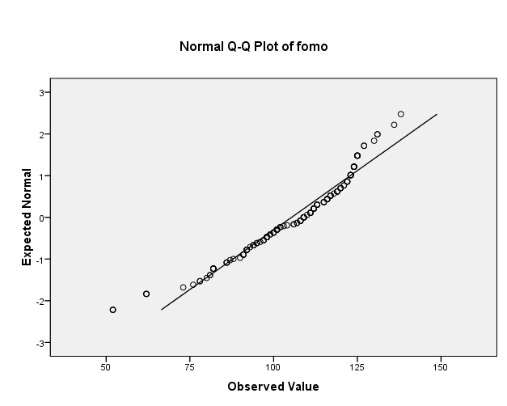

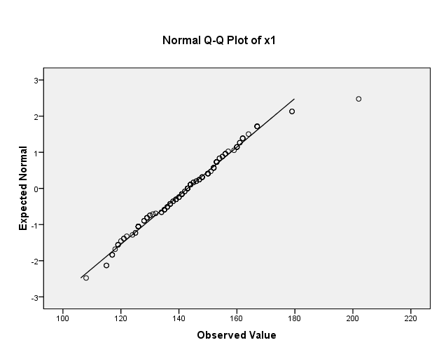

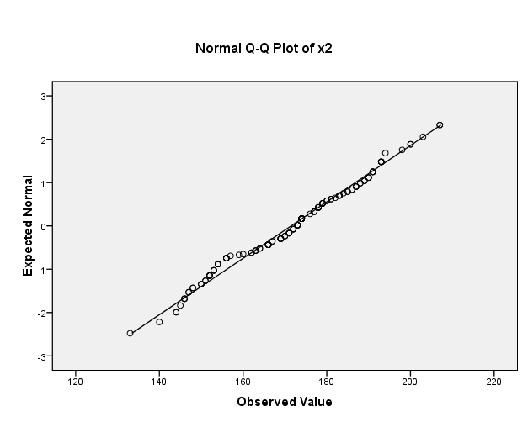

Lampiran 11
Hasil Uji Prasyarat – Linieritas

HASIL UJI LINIERITAS

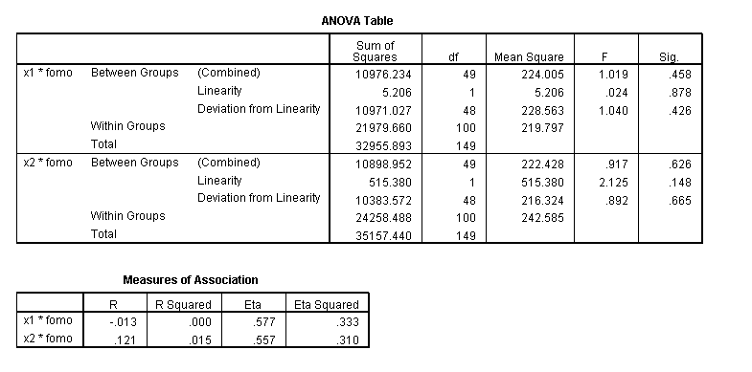

Lampiran 12
Hasil Uji Regresi Linier Berganda

HASIL UJI REGRESI LINIER BERGANDA

Variables Entered/Removed^{b}
Model | Variables Entered | Variables Removed | Method
1 | X2, X1ª | . | Enter
a. All requested variables entered.
b. Dependent Variable: Y

Model Summary
Model | R | R Square | Adjusted R Square | Std. Error of the Estimate
1 | .176ª | .031 | .018 | 17.382
a. Predictors: (Constant), X2, X1

ANOVA^{b}
Model |  | Sum of Squares | df | Mean Square | F | Sig.
1 | Regression | 1427.727 | 2 | 713.864 | 2.363 | .098ª
 | Residual | 44413.106 | 147 | 302.130
 | Total | 45840.833 | 149
a. Predictors: (Constant), X2, X1
b. Dependent Variable: Y

Coefficientsª
Model |  | Unstandardized Coefficients |  | Standardized Coefficients | t | Sig.
 |  | B | Std. Error | Beta
1 | (Constant) | 87.954 | 16.449 |  | 5.347 | .000
 | X1 | -.206 | .130 | -.174 | -1.582 | .116
 | X2 | .273 | .126 | .239 | 2.168 | .032
a. Dependent Variable: Y

