Lampiran 1
Kartu Bimbingan
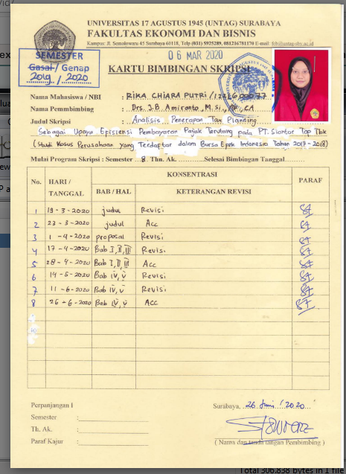

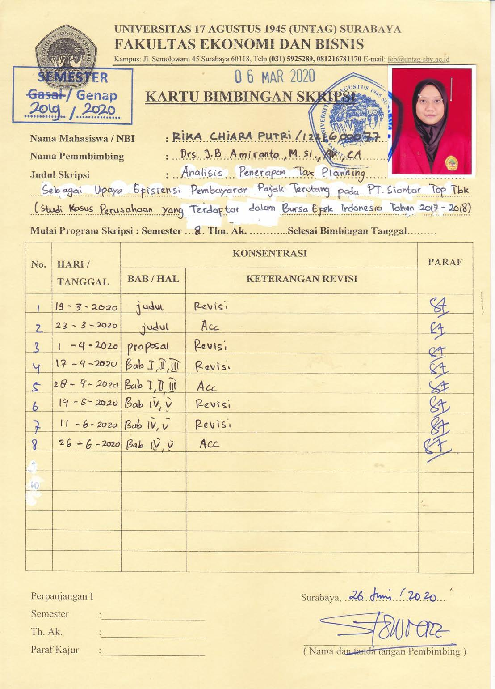
Lampiran 2
Hasil Turnitin
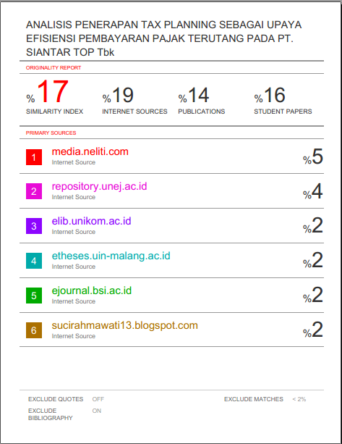

Lampiran 3
Tebel 4.1 Neraca PT. Siantar Top Tbk
Keterangan | Tahun 2017 | Tahun 2018
ASET  Aset Lancar:  - Kas dan Setara Kas  - Investasi Jangka Pendek  - Piutang Usaha  - Pihak ketiga  - Pihak Relasi  - Piutang lain-lain  - Pihak ketiga  - Pihak Relasi  - Persediaan  - Pajak dibayar dimuka  - Beban dibayar dimuka  - Uang muka, lancar  Jumlah Aset Lancar  Aset Tidak Lancar  - Piutang lain-lain  - Uang muka, tidak lancar  - Investasi pada entitas soaial  - Taksiran tagihan pajak penghasilan  - Aset Pengampunan pajak  - Properti investasi  - Aset tetap  - Aset lain-lain  Jumlah Aset Tidak Lancar | 69.954.867.440  164.534.645.272  122.580.584.762  247.714.130.353  18.217.201.244  325.000.000  299.078.174.645  11.743.287.958  8.157.528.085  5.680.630.608  947.986.050.367  19.644.600.000  180.118.610.882  -  533.322.000  26.570.278.000  37.656.473.492  1.125.768.977.479  4.154.130.976  1.394.446.392.829 | 64.106.808.475  345.143.161.701  158.456.254.158  163.919.643.957  21.971.963.624  4.135.871  313.291.338.820  4.272.154.627  7.895.139.093  71.746.222.592  1.250.806.822.918  20.997.450.000  178.635.676.344  8.749.718.464  1.117.994.000  26.570.278.000  40.481.811.912  1.096.143.561.950  6.596.077.395  1.380.382.987.112
TOTAL ASET | 2.342.432.443.196 | 2.631.189.810.030
LIABILITAS DAN EKUITAS  Liabilitas Jangka Pendek  - Utang bank  - Utang usaha, pihak ketiga  - Utang lain-lain  - Pihak ketiga  - Pihak berelasi  - Utang Pajak  - Beban masih harus dibayar  - Pendapatan diterima dimuka  - Uang muka penjualan  - Utang bank jangka panjang  - Utang obligasi  Jumlah Liabilitas Jangka Pendek  Liabilitas Jangka Panjang  - Liabilitas Pajak Tangguhan  - Utang bank jangka panjang  - Utang obligasi  - Liabilitas atas imbalan kerja  - Jaminan pelanggan  Jumlah Liabilitas Jangka Panjang | 20.085.487.830  191.057.166.317  34.651.593.554  10.175.791.350  31.185.152.877  45.254.264.467  1.310.104.333  16.618.464.539  -  358.963.437.494  23.773.818.194  14.687.647.768  498.298.611.105  58.829.749.764  3.107.110.511  598.696.937.342 | 18.598.095.933  232.453.396.104  38.760.736.070  6.377.000.000  3.804.791.041  53.663.959.436  440.933.333  22.883.882.942  299.690.770.049  676.673.564.908  34.190.909.530  -  199.383.242.197  71.886.588.749  2.667.557.694  308.128.298.170
TOTAL LIABILITAS | 957.660.374.836 | 984.801.863.078
EKUITAS  Ekuitas saham- nilai nominal Rp. 100 per saham Modal dasar 3.000.000.000 saham  Modal ditempatkan dan disetor penuh – 1.310.000.000.000 saham  - Tambahan modal disetor  - Saldo laba  - Komponen ekuitas lainnya  Sub- Jumlah  - Kepentingan non-pengendali  Jumlah Ekuitas | 131.000.000.000  1.347.146.100  1.247.680.784.928  (7.815.367.960)  1.372.212.563.068  12.559.505.292  1.384.772.068.360 | 131.000.000.000  1.347.146.100  1.502.876.626.810  (4.658.375.387)  1.630.565.397.523  15.822.549.429  1.646.387.946.952
TOTAL LIABILITAS DAN EKUITAS | 2.342.432.443.196 | 2.631.189.810.030

Lampiran 4
Tabel 4.2 Laporan Laba Rugi PT Siantar Top Tbk
Keterangan | Tahun 2017 | Tahun 2018
Penjualan bersih | 2.825.409.180.889 | 2.826.957.323.397
Baban Pokok Penjuakan | (2.211.949.522.001) | (2.207.268.926.068)
Laba Kotor | 613.459.658.888 | 619.688.397.329
Pendapatan lain-lain | 63.768.403.644 | 61.558.591.060
Beban Penjualan | (187.164.072.650) | (168.669.440.713)
Beban Umum & Administrasi | (100.764.758.001) | (112.859.616.510)
Beban keuangan | (71.977.480.135) | (54.067.624.513)
Beban lain-lain | (28.775.932.143) | (20.955.656.478)
Total biaya operasi | 244.777.415.959 | 263.136.059.115
Laba Sebelum Pajak | 288.545.819.603 | 324.694.650.175

Lampiran 5
Tabel 4.3 Rekonsiliasi Fiskal PT. Siantar Top Tbk Sebelum Tax Planning
Tahun 2017
Keterangan | Komersial | Koreksi Fiskal | Fiskal
Penjualan bersih | 2.825.409.180.889 |  | 2.825.409.180.889
Baban Pokok Penjuakan | (2.211.949.522.001) |  | (2.211.949.522.001)
Laba Kotor | 613.459.658.888 |  | 613.459.658.888
Pendapatan lain-lain | 63.768.403.644 |  | 63.768.403.644
Beban Penjualan | (187.164.072.650) |  | (187.164.072.650)
Beban Umum & Administrasi | (100.764.758.001) |  | (100.764.758.001)
Beban keuangan | (71.977.480.135) |  | (71.977.480.135)
Beban lain-lain | (28.775.932.143) |  | (28.775.932.143)
Total biaya operasi | 388.682.242.929 |  | 388.682.242.929
Laba Sebelum Pajak | 288.545.819.603 |  | 288.545.819.603

Lampiran 6
Tabel 4.4 Rekonsiliasi Fiskal PT Siantar Top Tbk Tahun 2018
Keterangan | Komersial | Koreksi Fiskal | Fiskal
Penjualan bersih | 2.826.957.323.397 |  | 2.826.957.323.397
Baban Pokok Penjualan | (2.207.268.926.068) |  | (2.207.268.926.068)
Laba Kotor | 619.688.397.329 |  | 619.688.397.329
Pendapatan lain-lain | 61.558.591.060 |  | 61.558.591.060
Beban Penjualan | (168.669.440.713) |  | (168.669.440.713)
Beban Umum & Administrasi | (112.859.616.510) |  | (112.859.616.510)
Beban keuangan | (54.067.624.513) |  | (54.067.624.513)
Beban lain-lain | (20.955.656.478) |  | (20.955.656.478)
Total biaya operasi | 294.993.747.154 |  | 294.993.747.154
Laba Sebelum Pajak | 324.694.650.175 |  | 324.694.650.175

Lampiran 7
Tabel Penerapan Tax Planning PT. Siantar Top Tbk untuk Biaya Pendidikan dan Pengembangan SDM Tahun 2017
Keterangan | Komersial | Koreksi Fiskal | Fiskal
Penjualan bersih | 2.825.409.180.889 |  | 2.825.409.180.889
Baban Pokok Penjuakan | (2.211.949.522.001) |  | (2.211.949.522.001)
Laba Kotor | 613.459.658.888 |  | 613.459.658.888
Pendapatan lain-lain | 63.768.403.644 |  | 63.768.403.644
Beban Penjualan | (187.164.072.650) |  | (187.164.072.650)
Beban Umum & Administrasi | (100.764.758.001) |  | (100.764.758.001)
Beban keuangan | (71.977.480.135) |  | (71.977.480.135)
Biaya Pendidikan dan Pengembangan SDM | (490.299.509) |  | (490.299.509)
Beban lain-lain | (28.775.932.143) |  | (28.775.932.143)
Total biaya operasi | 389.172.542.438 |  | 389.172.542.438
Laba Sebelum Pajak | 160.518.712.806 |  | 160.518.712.806

Lampiran 8
Tabel Penerapan Tax Planning PT. Siantar Top Tbk untuk Biaya Pendidikan dan Pengembangan SDM Tahun 2018
Keterangan | Komersial | Koreksi Fiskal | Fiskal
Penjualan bersih | 2.826.957.323.397 |  | 2.826.957.323.397
Baban Pokok Penjuakan | (2.207.268.926.068) |  | (2.207.268.926.068)
Laba Kotor | 619.688.397.329 |  | 619.688.397.329
Pendapatan lain-lain | 61.558.591.060 |  | 61.558.591.060
Beban Penjualan | (168.669.440.713) |  | (168.669.440.713)
Beban Umum & Administrasi | (112.859.616.510) |  | (112.859.616.510)
Beban keuangan | (54.067.624.513) |  | (54.067.624.513)
Beban lain-lain | (20.955.656.478) |  | (20.955.656.478)
Biaya Pendidikan dan Pengembangan SDM | (225.116.110) |  | (225.116.110)
Total biaya operasi | 295.218.863.264 |  | 295.218.863.264
Laba Sebelum Pajak | 262.910.943.005 |  | 262.910.943.005

Lampiran 9
Tabel 4.9 Penerapan Tax Planning PT. Siantar Top Tbk untuk Biaya Imbalan Kerja Tahun 2017
Keterangan | Komersial | Koreksi Fiskal | Fiskal
Penjualan bersih | 2.825.409.180.889 |  | 2.825.409.180.889
Baban Pokok Penjuakan | (2.211.949.522.001) |  | (2.211.949.522.001)
Laba Kotor | 613.459.658.888 |  | 613.459.658.888
Pendapatan lain-lain | 63.768.403.644 |  | 63.768.403.644
Beban Penjualan | (187.164.072.650) |  | (187.164.072.650)
Beban Umum & Administrasi | (100.764.758.001) |  | (100.764.758.001)
Beban keuangan | (71.977.480.135) |  | (71.977.480.135)
Biaya Imbalan Kerja | (14.381.510.266) |  | (14.381.510.266)
Beban lain-lain | (28.775.932.143) |  | (28.775.932.143)
Total biaya operasi | 403.063.753.195 |  | 403.063.753.195
Laba Sebelum Pajak | 146.627.502.049 |  | 146.627.502.049

Lampiran 10
Tabel 4.9 Penerapan Tax Planning PT. Siantar Top Tbk untuk Biaya Imbalan Kerja Tahun 2018
Keterangan | Komersial | Koreksi Fiskal | Fiskal
Penjualan bersih | 2.826.957.323.397 |  | 2.826.957.323.397
Baban Pokok Penjuakan | (2.207.268.926.068) |  | (2.207.268.926.068)
Laba Kotor | 619.688.397.329 |  | 619.688.397.329
Pendapatan lain-lain | 61.558.591.060 |  | 61.558.591.060
Beban Penjualan | (168.669.440.713) |  | (168.669.440.713)
Beban Umum & Administrasi | (112.859.616.510) |  | (112.859.616.510)
Beban keuangan | (54.067.624.513) |  | (54.067.624.513)
Beban lain-lain | (20.955.656.478) |  | (20.955.656.478)
Biaya Imbalan Kerja | (14.926.093.819) |  | (14.926.093.819)
Total biaya operasi | 309.919.840.973 |  | 309.919.840.973
Laba Sebelum Pajak | 248.209.965.296 |  | 248.209.965.296

