DAFTAR LAMPIRAN

Lampiran 1 : documentasi comparasion metode di google colab
Link url : https://colab.research.google.com/drive/15nJMqWTX1DnqSAznO4h-qYFg0koY3IHL

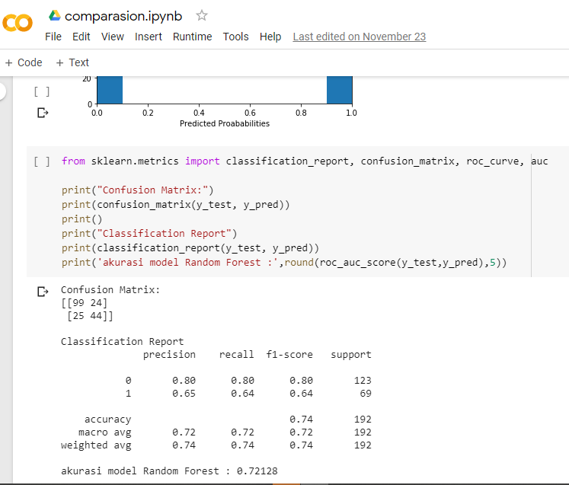

Gambar Lampiran 1 dokumentasi running program di google colaboraty

Lampiran 2 : dokumentasi pengembangan akurasi metode dengan deep learning
link url : https://colab.research.google.com/drive/1xP8c6qlcfaRiiheMeiao_wtpUE4PDhiJ

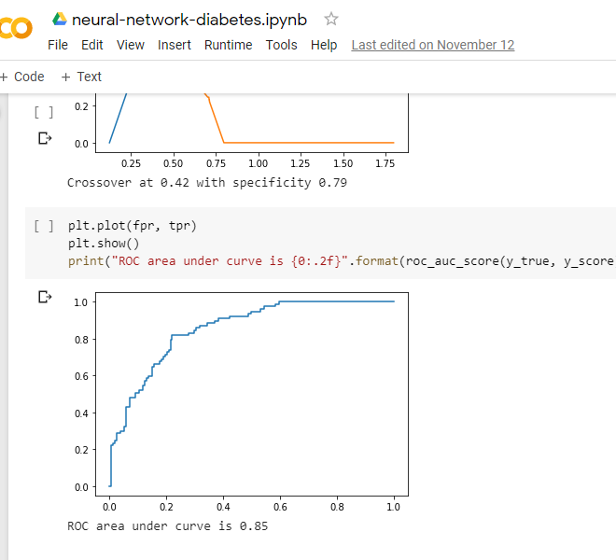

Gambar Lampiran 2 dokumentasi program deep learning di google colaboraty

Lampiran 3 : dokumentasi deploy machine learning di kaagle
Link url profile : https://www.kaggle.com/jpunior0/kernels
Link url deploy : https://www.kaggle.com/jpunior0/performance-accuration-method-of-machine-learning
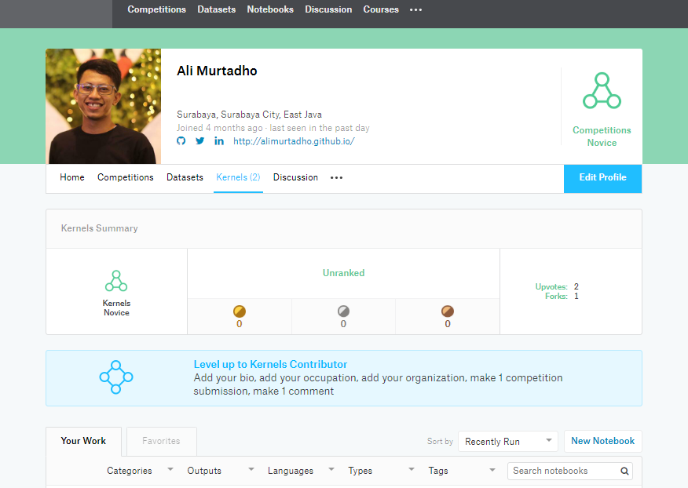

Gambar Lampiran 3 dokumentasi link url profile kaagle

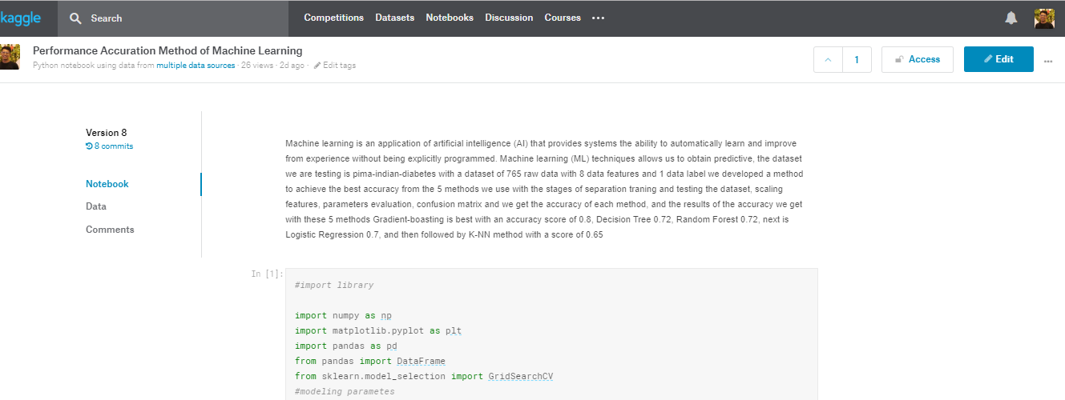

Gambar Lampiran 4 dokumentasi link deploy program di kaagle

Lampiran 4 : pengembangan program machine learnig apps
Link url : https://github.com/alimurtadho/

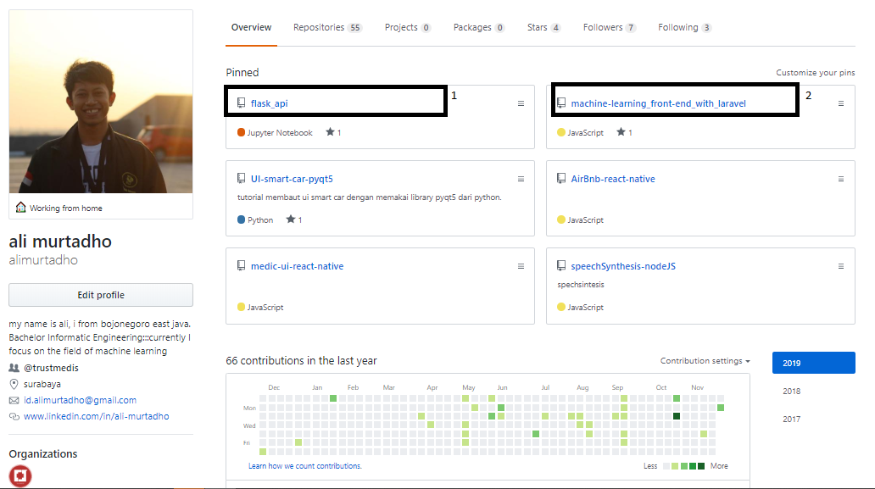

Gambar Lampiran 5 dokumentasi profile github dan pegembangan apps machine learning

Lampiran 5 publikasi jurnal lolos seleksi kompetisi BICMST “Brawijaya International Conference Multidisiplionary Sience and technology”

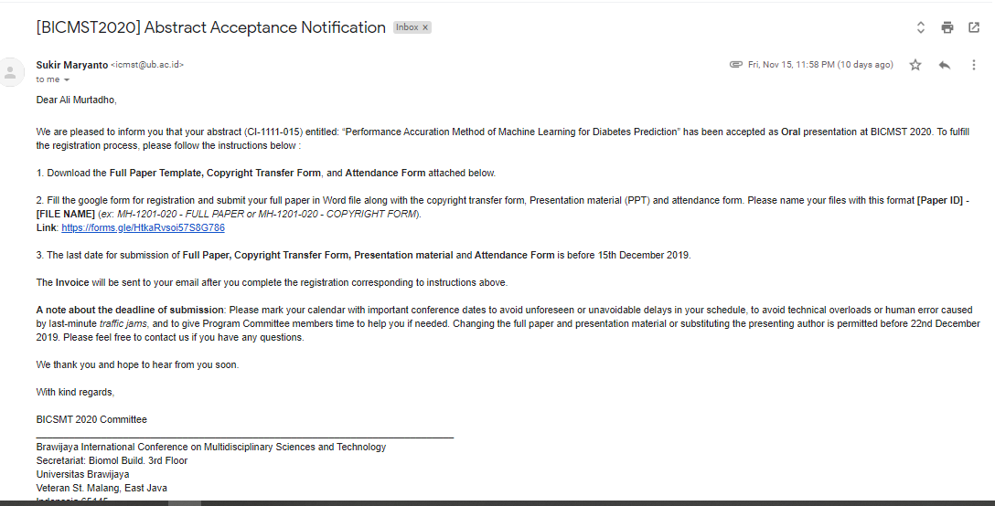

Gambar Lampiran 6 bukti publikasi jurnal

